Light Absorption: Black Paper vs. White Paper

Purpose: shows how sunlight is differently absorbed with the black paper representing the land and rocks, and the white representing the ice and glaciers

Materials:
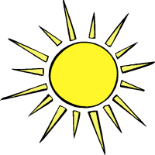
2 identical drinking glasses or jars
Water
Thermometer
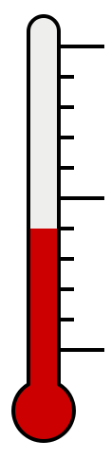
2 rubberbands
White paper
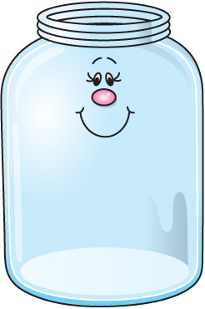
Black paper

Procedure:
- Wrap the white paper around one of the glasses using a rubberband to hold it on.
- Do the same with the black paper and the other glass.
- Fill the glasses with the exact same amount of water.
- Leave the glasses out in the sun for a couple of hours before returning to measure the temperature of the water in each.
Have students record the temperatures and write down their observations
Student Worksheet
Light Absorption: Black paper vs. White paper

Name____________________________
Directions: Measure and make sure the temperatures of both jars, which are covered with black paper and white paper, are same before putting them under sunlight. Then, check and record the temperature of both jars every 2 hours, maximum 6 hours, after putting them under the sun.

Time | Temperature of Jar with Black Paper | Temperature of Jar with  White Paper
(Before putting jars under the sunlight)
(2 Hours Later)
(4 Hours Later)
(6 Hours Later)

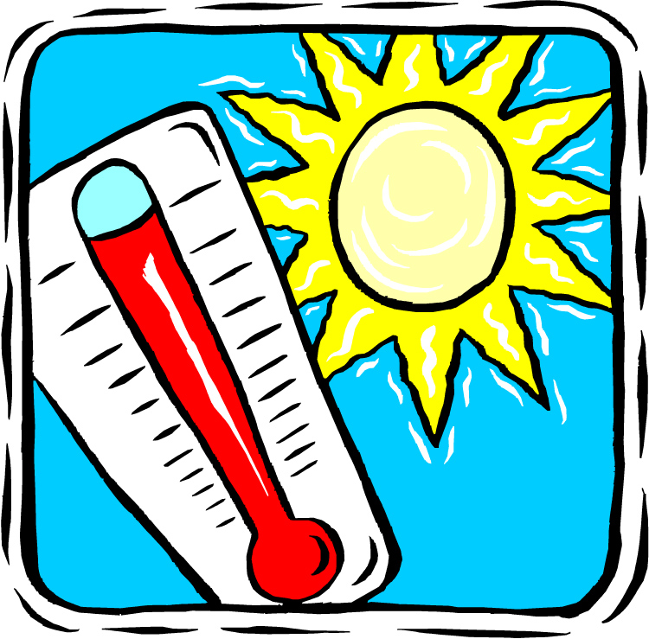

Name___________________
Questions

1. What happened to the temperature of the jar that was covered with white paper?

2. What happened to the temperature of the jar that was covered with black paper?

3. Which jar was hotter?

4. Why was the one jar hotter than the other?

5. What do black paper and white paper represent?

