Evaporation Lab Questions

1. Which cup has more water?

2. Which cup has less water?

3. Why does the cup with plastic have more water?
a) The plastic protects the water from disappearing
b) The plastic has holes
c) The plastic drinks the water

4. Why did the water disappear?
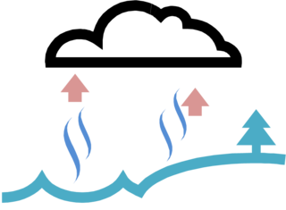
a) Because of the sun and heat
b) Because it was cold
c) Because it was cloudy

5. Where did the water go?
a) Into the dirt
b) Into the sky
c) Into the sidewalk
