What is a Thermometer?

A thermometer is something that measures how hot or cold it is! It is important because by telling us how hot or cold it is, we will know what to wear. You can read the temperature by looking at the numbers on the thermometer.

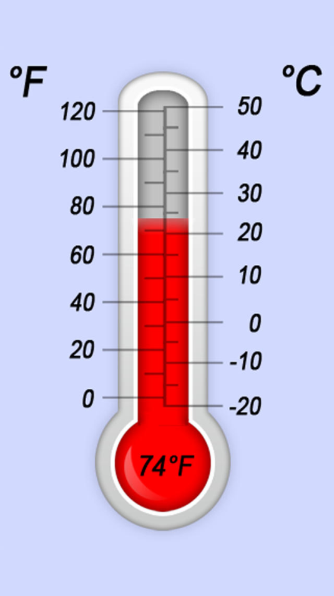

If the temperature is between 72 and 78, it is a very good temperature. If it is above 90, it is hot. Wear short sleeves and pants.

If it is below 60, it is cold. Wear a jacket, mittens, and long pants to keep warm.

