Week 2 Vocabulary List
- Hot- Very warm, like the sun
- Cold- Very cool, like ice

- Sun- A big sun that keeps Earth warm
- Cloudy- When the sky is full of clouds
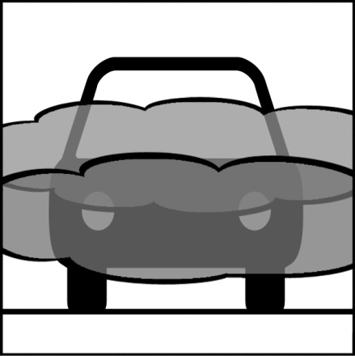
- Foggy- Clouds on the ground

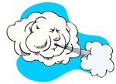
- Windy- Blasts of air
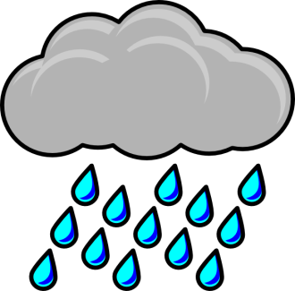
- Rainy- When drops of water fall from the sky

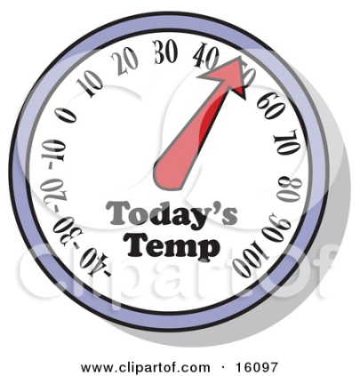
- Temperature- A number that shows you how hot or cold it is outside

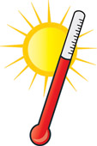
- Thermometer- Tool used to measure temperature

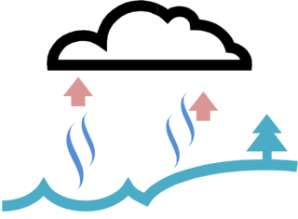
- Evaporate- When water dries up and goes to the sky

