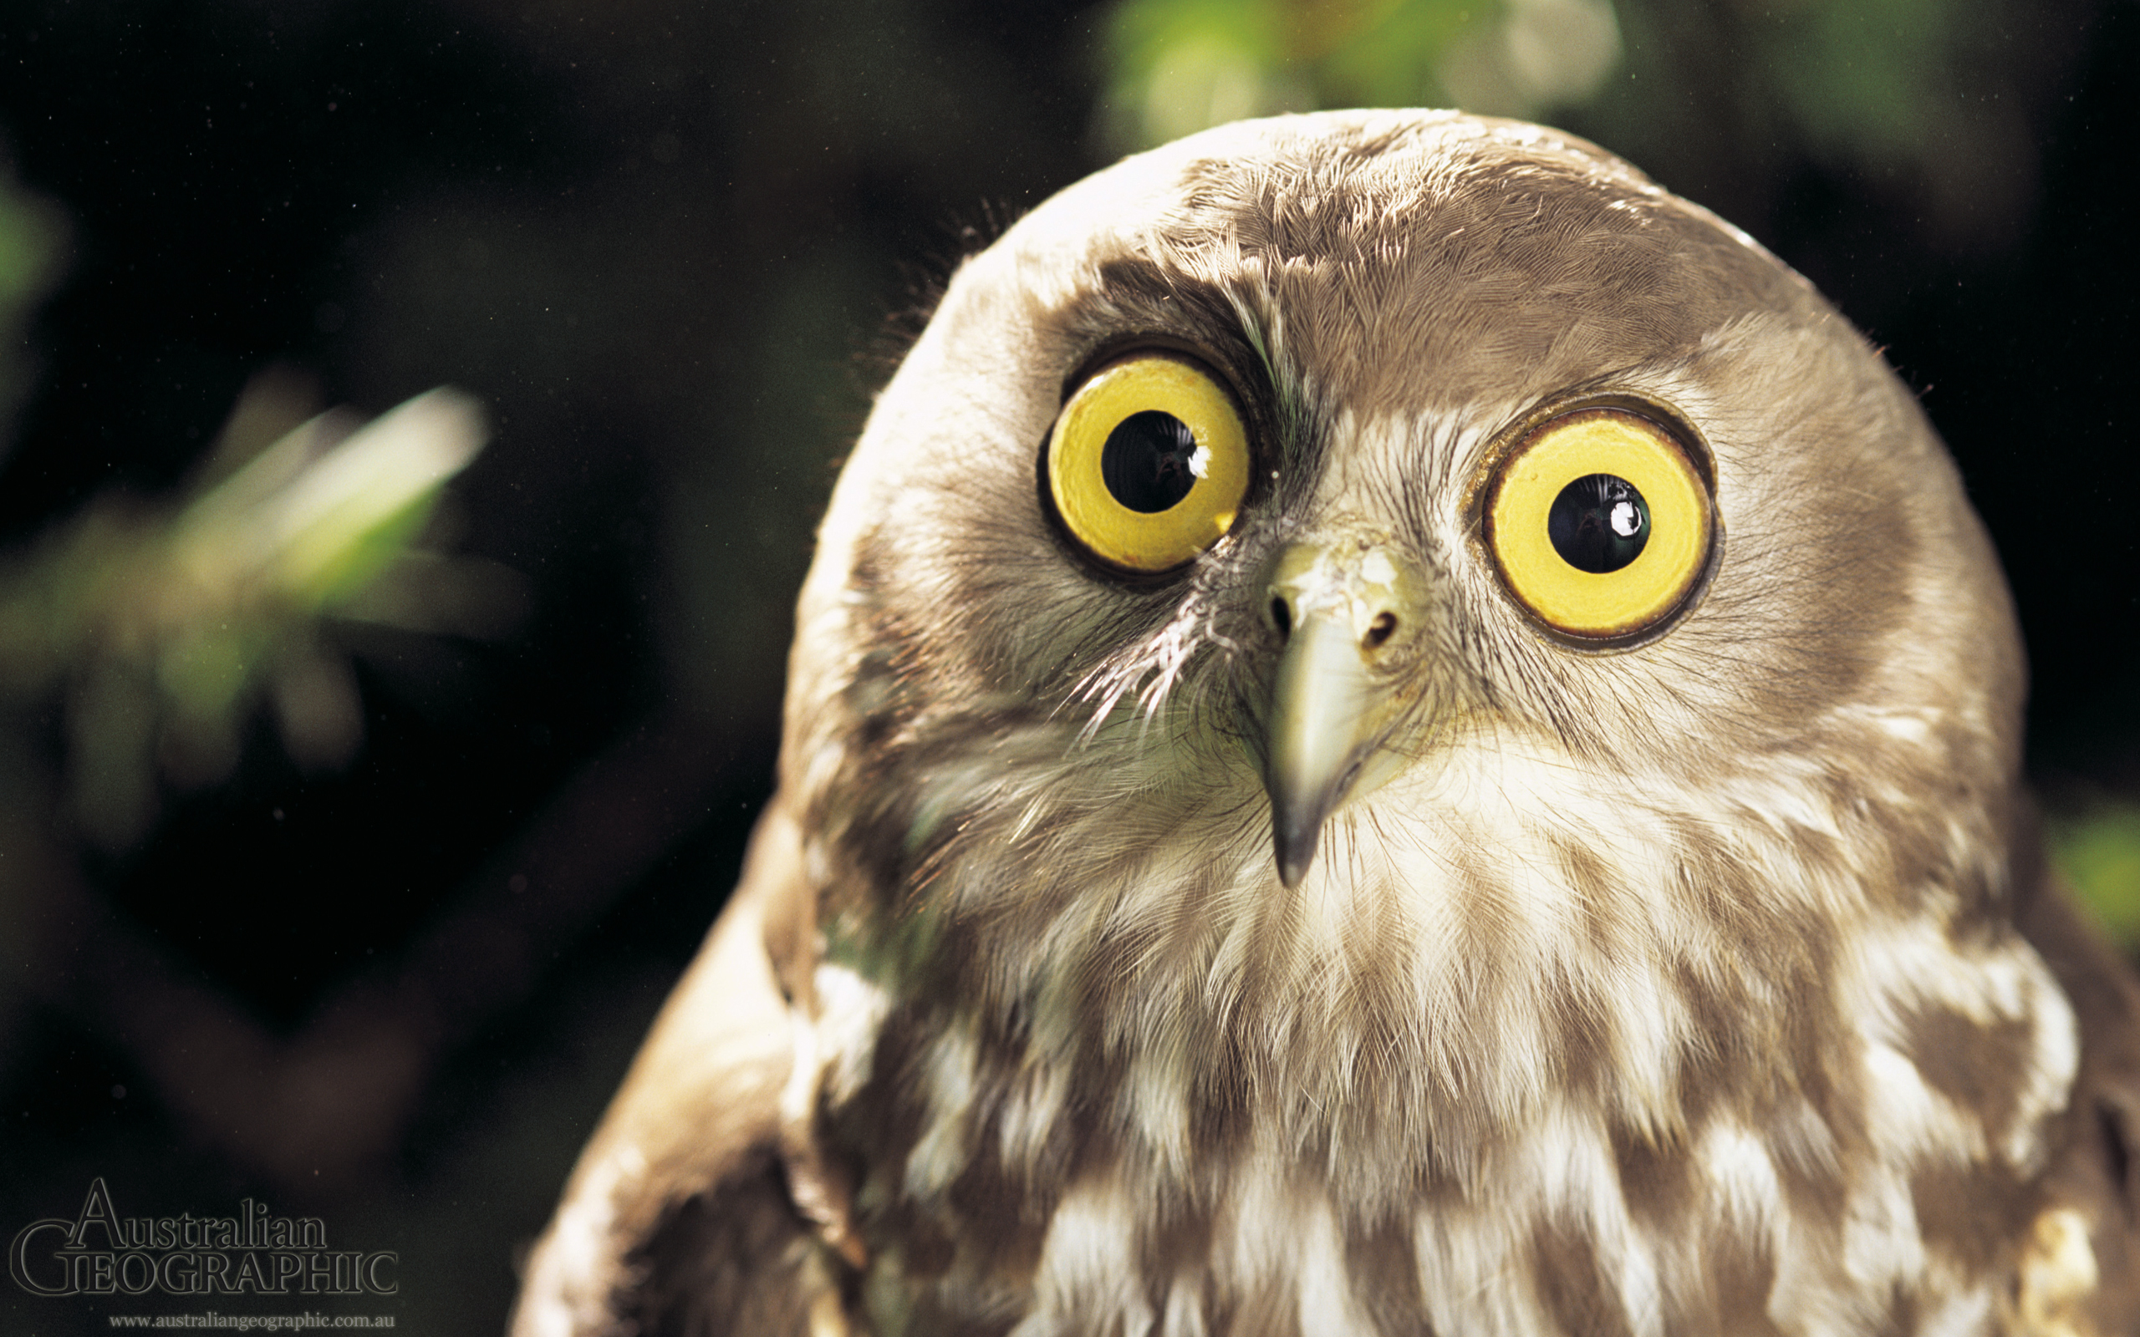
Animal Organ Reading Questions
1.What are vertebrates?
2.What are invertebrates?
3.What are the types of consumer?
4.What kind of limbs differ between animals?
5.Why is movement important for animals?

