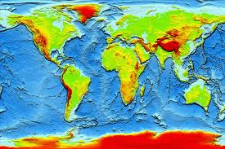
Topography Quiz
1. Topography is
a) the placement of plates
b)arrangement of the natural and artificial physical features of an area.
c) the study of topos

Matching Choose the correct letter for each term.

2.Plateau ______
3.Plain ______
4.Mountain ______
5.Landform ______

Choices:
a) Landform made up of nearly flat land
b)Landform with high elevation and level surface
c)Landform with high elevation
d)natural physical feature on Earth’s surface

6)What do oceans and seas have in common other than being just water?
a)smaller body of saltwater on ocean’s margins and partially enclosed by land
b)large body of saltwater
c)They include saltwater

Flip to the next page! →

Draw a line connecting the term to the matching picture
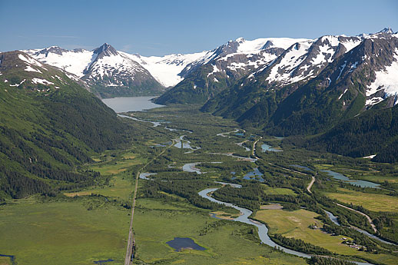
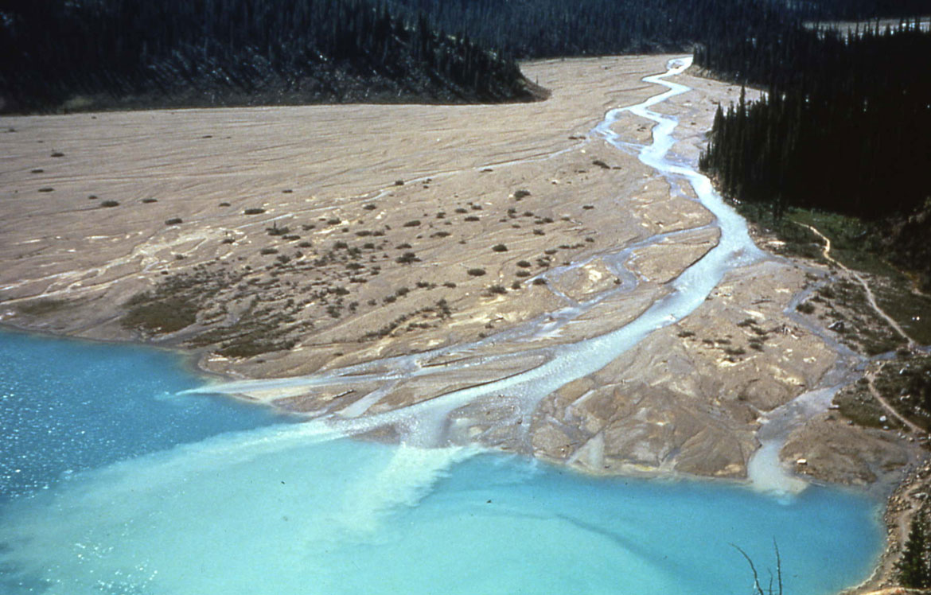
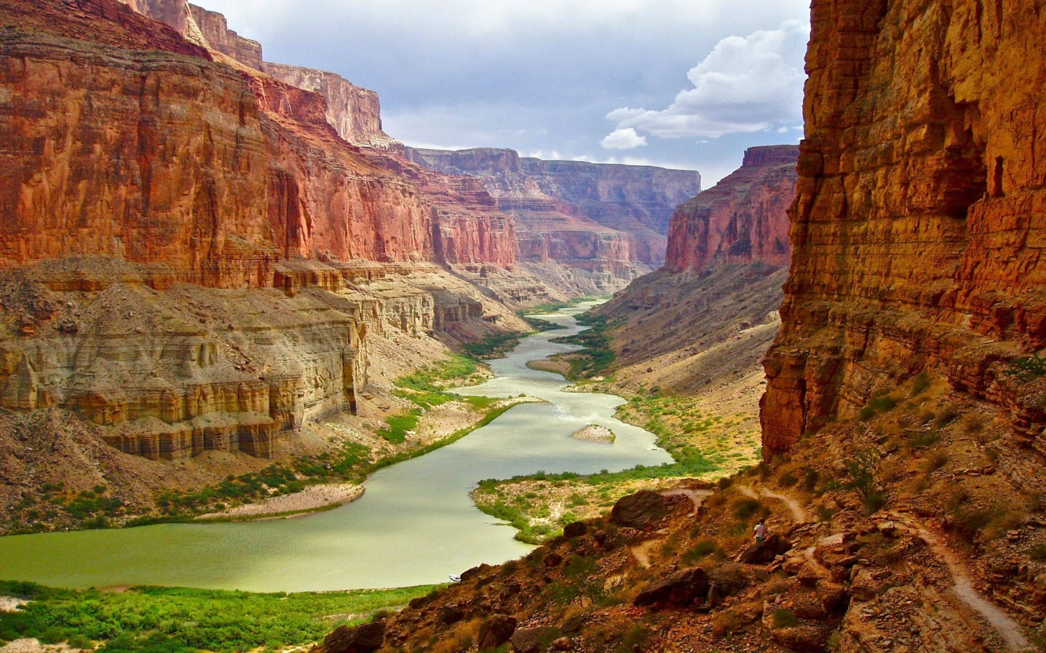

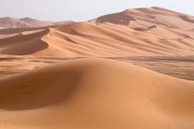
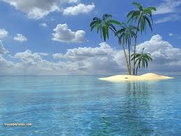
7)Valley 8)Canyon 9)Deltas 10)Dunes 11)Island

True or False? Write out TRUE or FALSE
(T and F will not be counted!)
12.______Lakes are a large body of water surrounded by ice.
13.______Glaciers are a large moving mass of ice.
14.______Rivers are natural streams of salt water flowing in a set course.

Bonus!
15.______ Ocean ________ is area between two divergent plates where magma rises and forms areas of increased elevation on the ocean floor.

