Name: _______________

Learn the Difference Between Climate and Weather

Fill in the blanks and answer the questions based on the video.
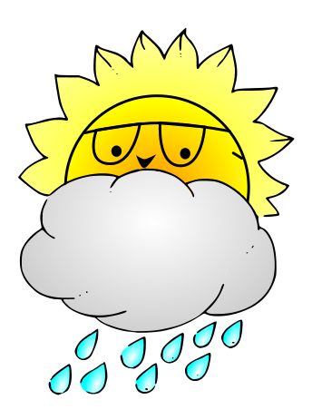
Questions:
- When temperatures are high the weather

is _______!

- When temperatures are low the weather is

_______!

- New York has _______ winters and ________

summers.

- Antarctica is ___________ all year long.

5) How long does the climate stay the same for?

