Answer Key

Learn the Difference Between Climate and Weather

Fill in the blanks and answer the questions based on the video.
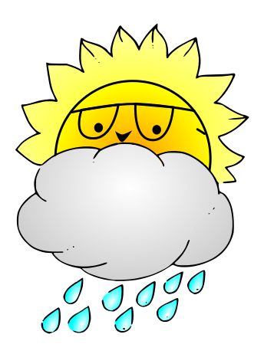
Questions:
- When temperatures are high the weather

is hot!

- When temperatures are low the weather is

cold!

- New York has cold winters and hot summers.

- Antarctica is cold all year long.

- How long does the climate stay the same for?
For long periods of time

