Answer Key
Sun Safe Play Everyday!

Questions:

- What does the sun help grow?
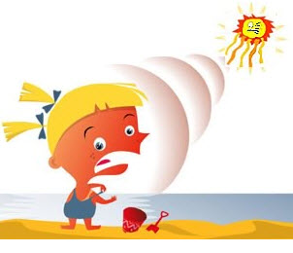
Grass, flowers, trees

- What do trees protect us from?

The Sun

- The sun gives us ___ and ____.

Light and heat

- What can sunrays cause to our skin?

Sunburn

5) What should we wear when we play outside?

Hat

