Teacher Key
What is Shade?
Questions:

1) What is hotter? Inside or outside?
Outside

2) What does the shade do?
Keeps you cool

3) What is the arrow pointing at?
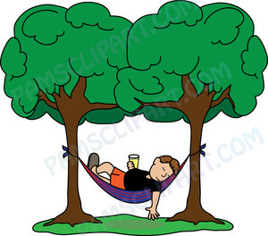
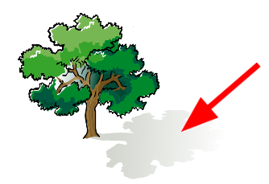

Answer: ____shade____

4) What does the shade protect you from?
Sunlight

5) The sunlight makes the ground ____hot____.

