Name: _______________

Outer Space: "I'm So Hot"

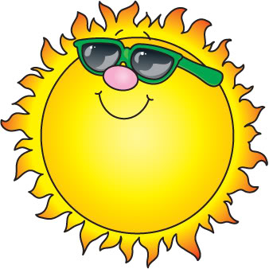
Questions:

- What is the sun made out of?

- How hot is the sun?

- The sun helps grow what?

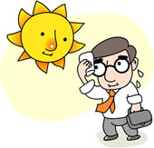
- The sun makes ____ dry.

5) What do you feel if the sun is not around?

