C:\Users\LexCom\AppData\Local\Microsoft\Windows\Temporary Internet Files\Content.IE5\6HCTOHR0\MC900232180[1].wmfName:___________________

Video QuestionsC:\Users\LexCom\AppData\Local\Microsoft\Windows\Temporary Internet Files\Content.IE5\YD9WLWVF\MC900383360[1].wmf

1. What are we using when we try to pull or push something?
2. Can force change direction of things? (yes/ no)
3. What is done when force can move something?

C:\Users\LexCom\AppData\Local\Microsoft\Windows\Temporary Internet Files\Content.IE5\6HCTOHR0\MC900281333[1].wmf

1. What is the ability to work?
2. Can energy be moved? (yes/ no)
3. What type of energy did the fire have?
4. Where does solar energy come from?
5. 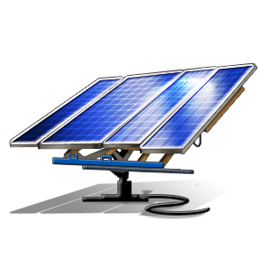What type of panel stores solar energy?
6. What type of energy does water produce?
7. What are the things that produce electricity through wind energy called?

C:\Users\LexCom\AppData\Local\Microsoft\Windows\Temporary Internet Files\Content.IE5\6HCTOHR0\MC900441874[1].wmf