Name: ___________________________________ Date: _________________

Environment Quiz

Directions: Fill in the blank. A word bank is provided for you.

1. A(n) _______________ is a physical place where an animal or plant naturally lives and grows, while a(n) _______________ is the role an animal plays in its environment.

2. Some natural _______________ in an organism’s environment are food, water, and shelter.

3. A poor environment and a lack of nutrients may cause _______________ in organisms.

4. Some animals are _______________, like cows and sheep, while other animals are _______________, like lions and bears.

5. _______________ is the general pattern of the atmosphere.

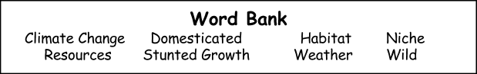
6. On the other hand, the long-term change in the weather of an area is _______________ _______________.

