How Light Enters the Eye Reading
As soon as light exits its source, it reflects off the first object it hits and enters the eye. The outermost protective layer is the cornea, which focuses the light into the pupil. After light enters the pupil, it hits the lens. The lens sits behind the iris and is clear and colorless. The lens' job is to focus light rays on the back of the eyeball — a part called the retina (say: RET-i-nuh). The lens works much like the lens of a movie projector at the movies. Next time you sit in the dark theater, look behind you at the stream of light coming from the projection booth. This light goes through a powerful lens, which is focusing the images onto the screen, so you can see the movie clearly. In the eye's case, however, the film screen is your retina. Your retina is in the very back of the eye. It holds millions of cells that are sensitive to light. The retina takes the light the eye receives and changes it into nerve signals so the brain can understand what the eye is seeing.
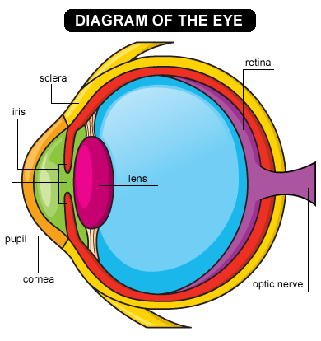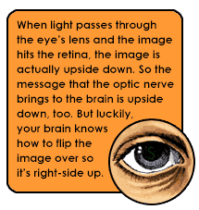

How Light Enters the Eye Reading Questions

1. What is the outermost layer of the eye?

2. Name 3 examples of a light source.

3. What does the cornea focus the light onto?

4. The lens focuses the light onto the ______.

5. Where does the retina send the light signals?

