A Big Star
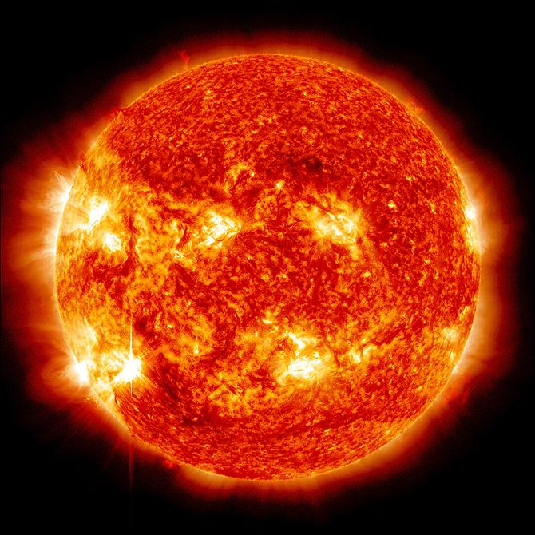
What is big and bright? What gives Earth its light? The sun!
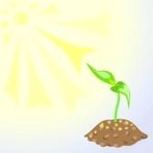
The sun is a star that is close to Earth. It is a ball of fire and gas.

It gives Earth heat and light. Living things need heat and light.

What would Earth be like without the sun?

Name:__________________ Date:_________

Directions: For questions 1-4, circle the correct answer.

1.What gives Earth its light?
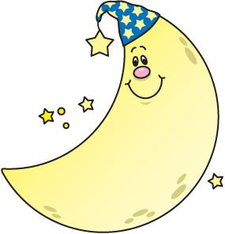
the sun the moon

2. What is the sun?

a light bulb a star

3.What is the sun made of?
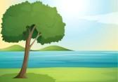
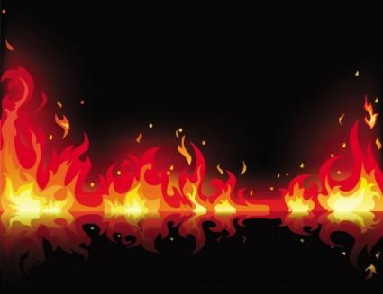

rivers and trees fire and gas
4. What planet is the sun close too?
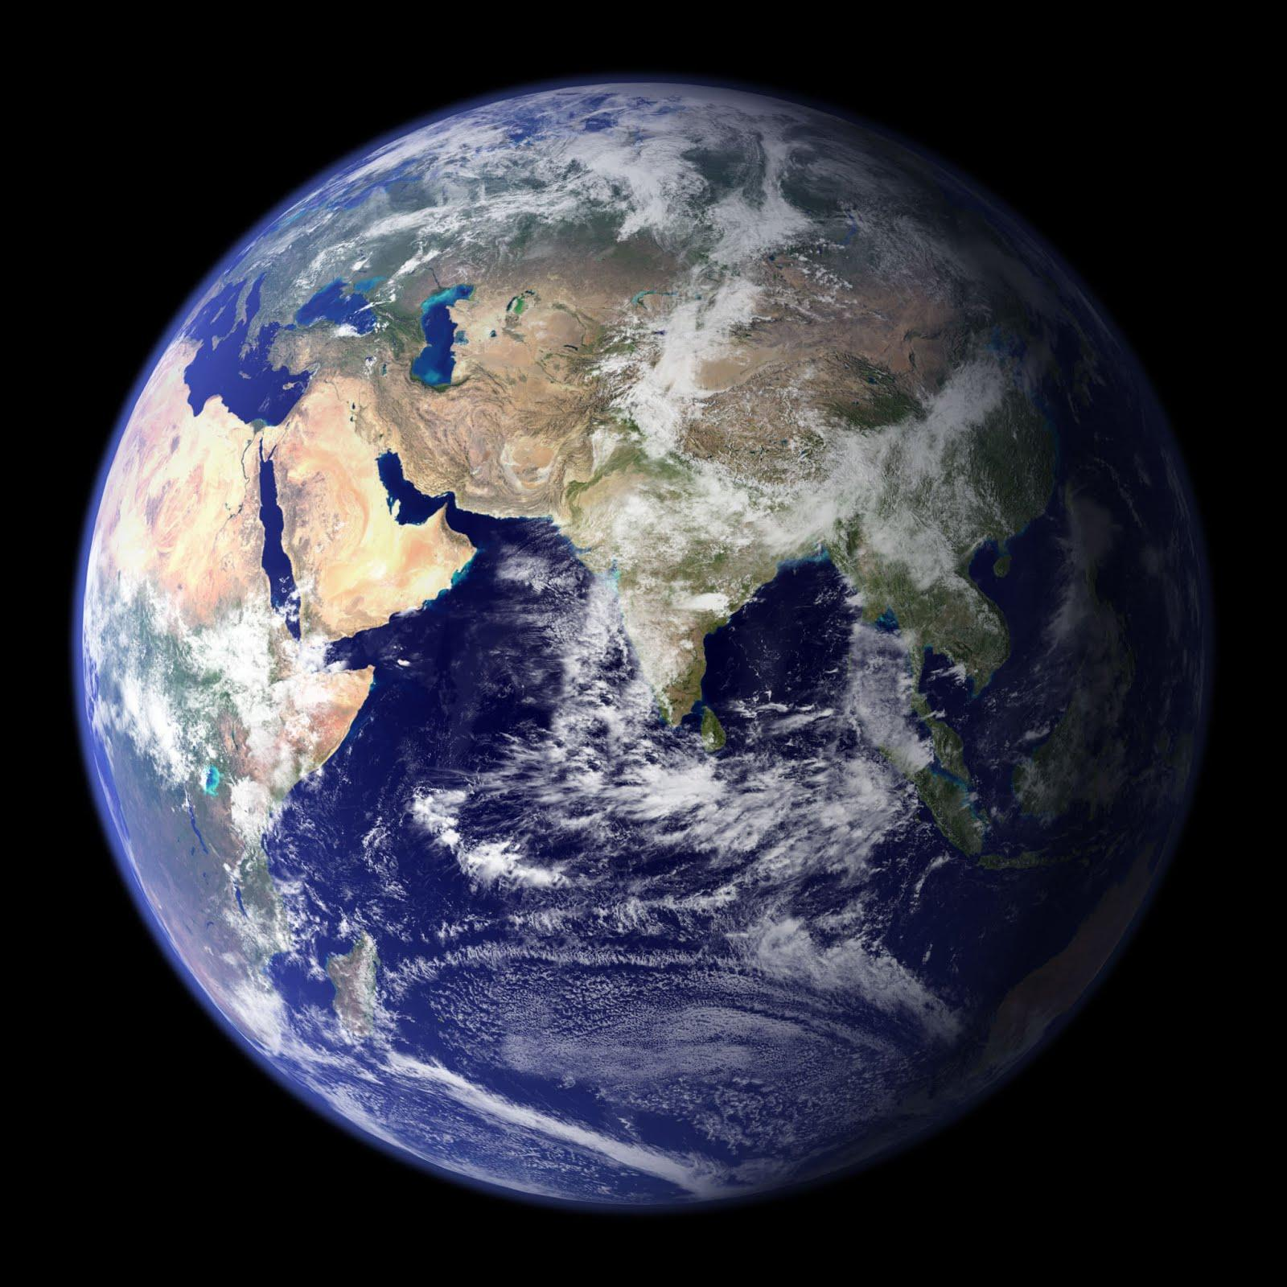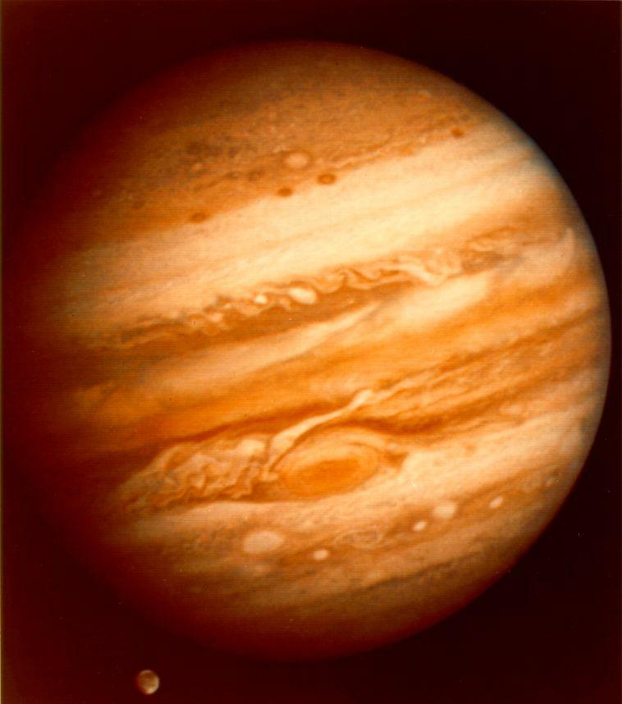
Earth Jupiter

5. What does the sun give to Earth?
_________________________________________________

_ _ _ _ _ _ _ _ _ _ _ _ _ _ _ _ _ _ _ _ _ _ _ _ _ _ _ _ _ _ _ _ _ _

_________________________________________________

6. Draw a picture of the sun!

