Name:__________________________________ Date:_________________

Beaded Necklace/Bracelet Experiment!! (Week 2)
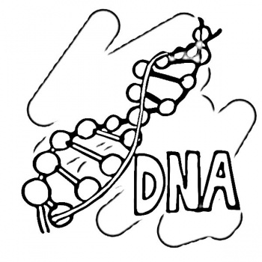

Introduction
Do you know what monomers are? Monomers are like the beads in a necklace, they connect to make an entire necklace! The connected monomers are called Polymers. They are important because everything around you is made of polymers.

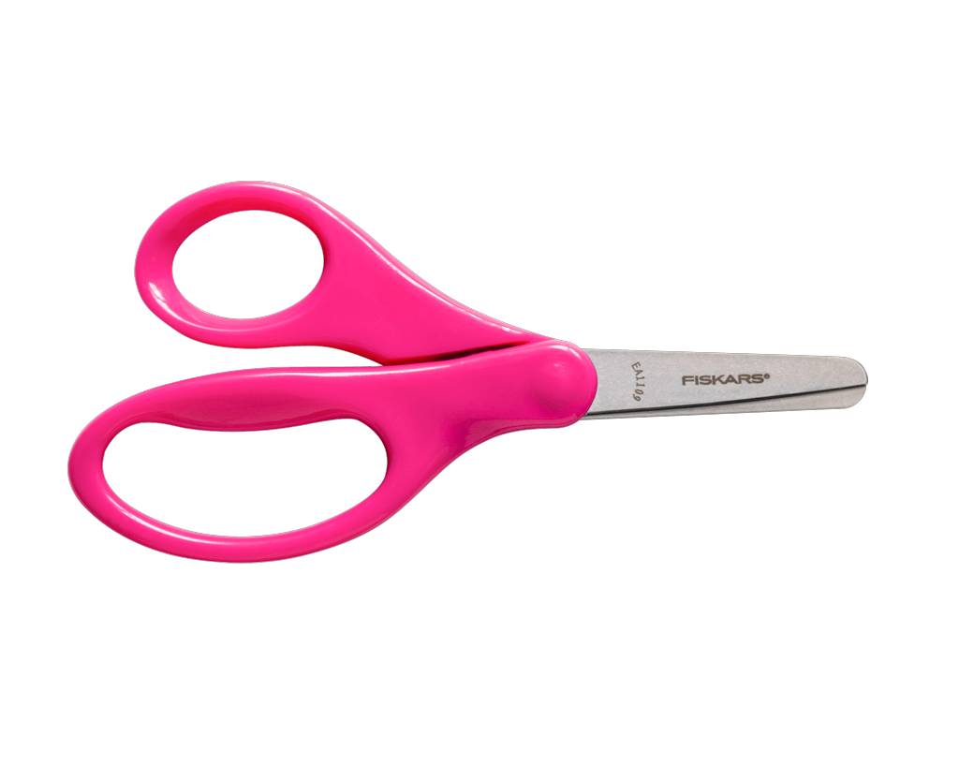
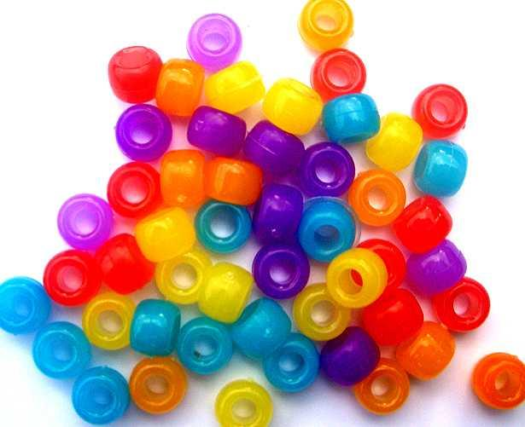
Materials:
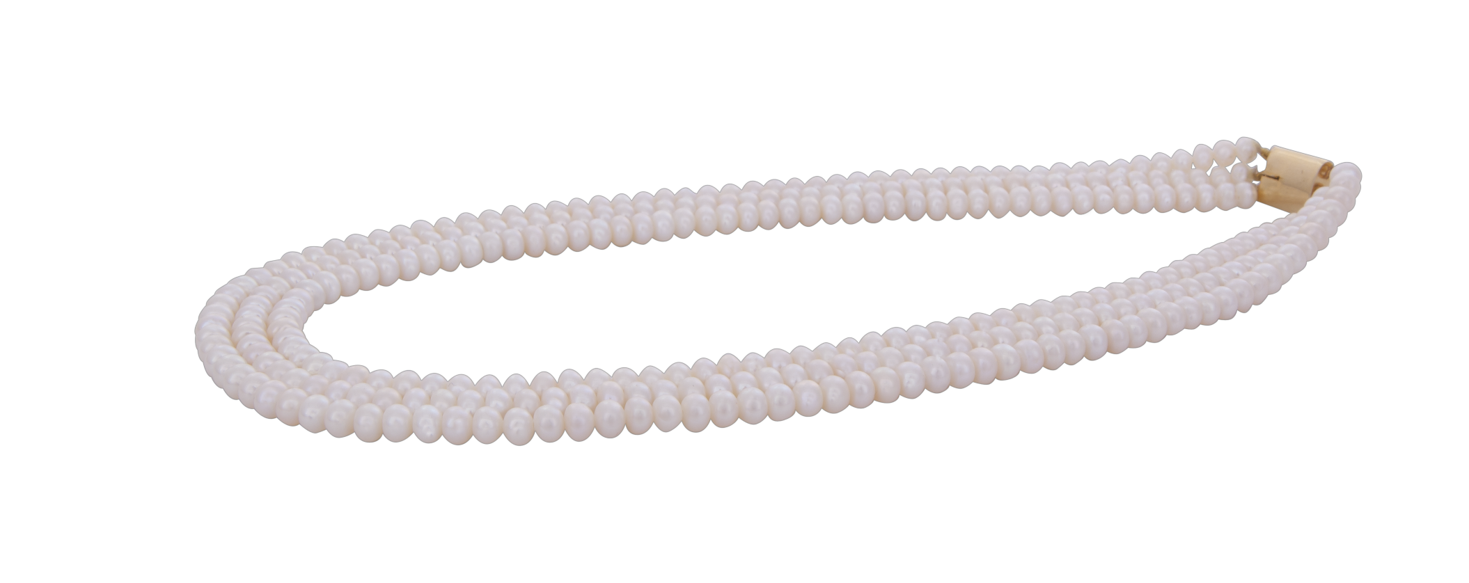
-Beads
-Strings
-Scissors

Procedure
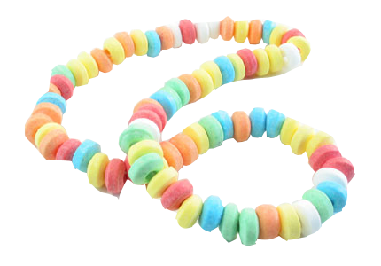
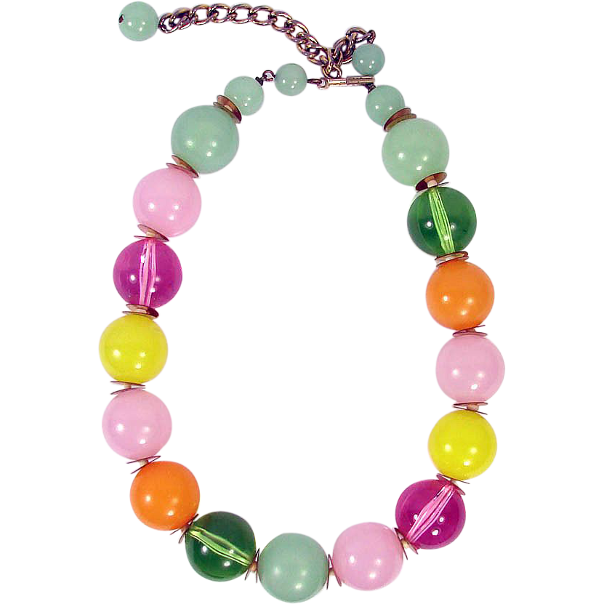
- Take 15 beads of different colors, and one string.
- Measure the size of your neck or wrist.
- Start making your necklace/bracelet!
- Tell the teacher when you are done.
- Make 3 more designs
- Tell teacher when you are done with each design

