Shadows
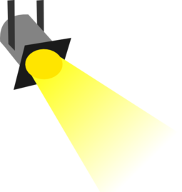
Light comes from different sources, such as the Sun, light bulbs, and candles. When light shines on a wall, the ground or a piece of paper, it makes that thing look bright.
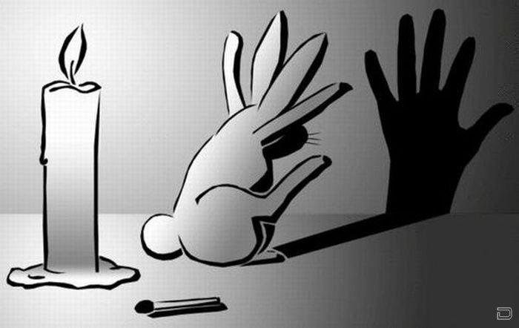
When no light is shining, everything looks dark. By putting an object, like your hand, between a light source and a surface, you make a shadow. A shadow is a place where no light is shining.
Name:__________________ Date:_________

Directions: For # 1-4, match the pictures to the right description.
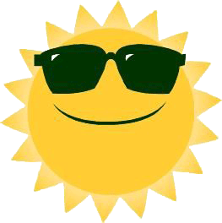
1.)
a place where no light is shining

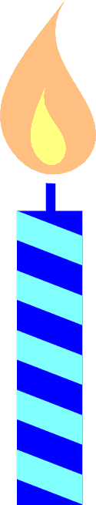
2.)
a big bright star that gives Earth its light

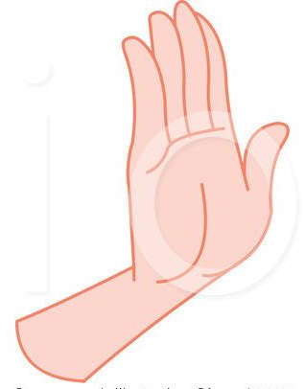
3.)
a source of light

4.)

something that can be used to block light

5.) Draw a shadow for the girl. Make sure it is in the right position. (Hint: look at where the sun is)

