Teacher’s Key

1) What can melt under the sun?
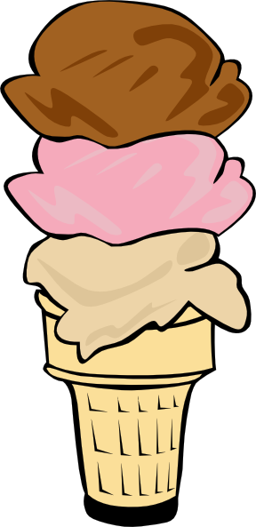

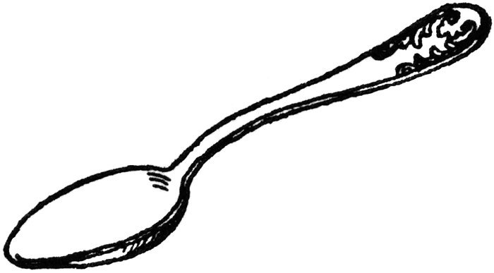

Ice Cream Spoon

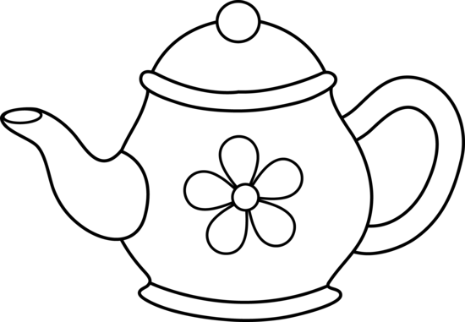
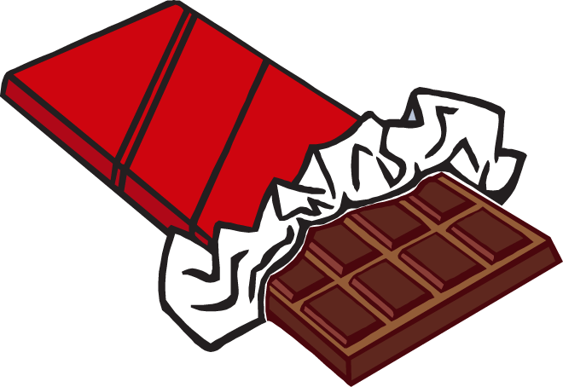

Teapot Chocolate Bar

2) What can freeze in cold temperature?

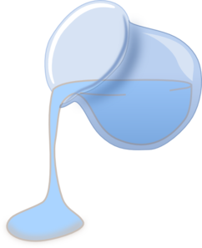
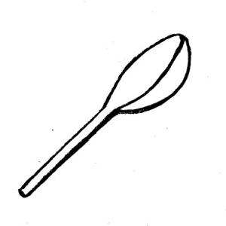

Water Spoon

3) Which one has high, medium, and low temperature?

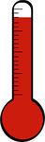
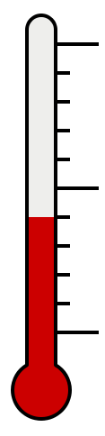
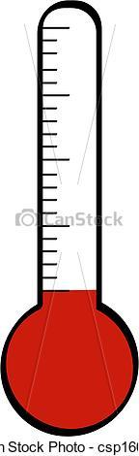

________ ________ ________

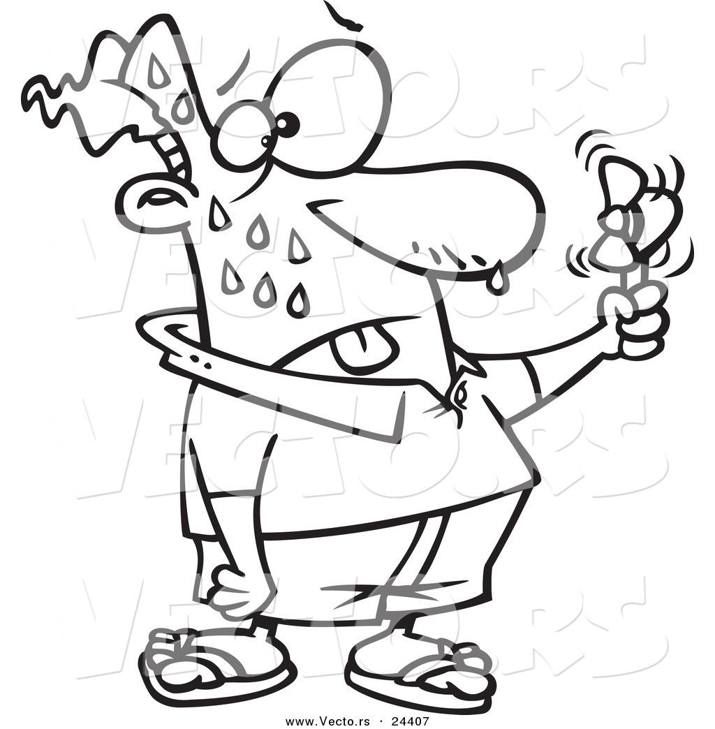
4) What happens when you are hot?

You Sweat.

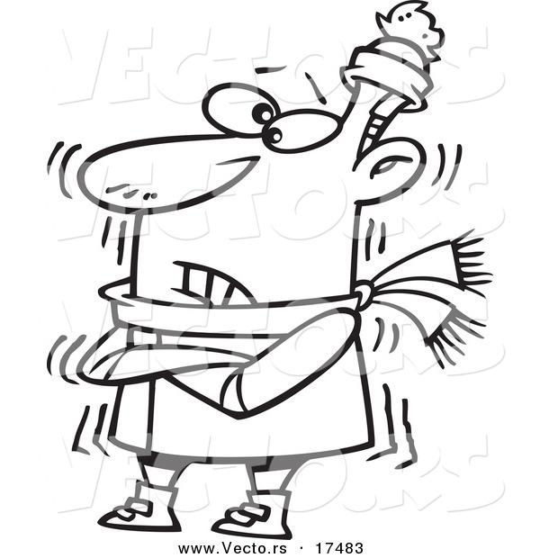
5) What happens when you are cold?

You shiver.

