**Week 4 Quiz**

1. Shades can help you feel ________.

a) Hot b) cool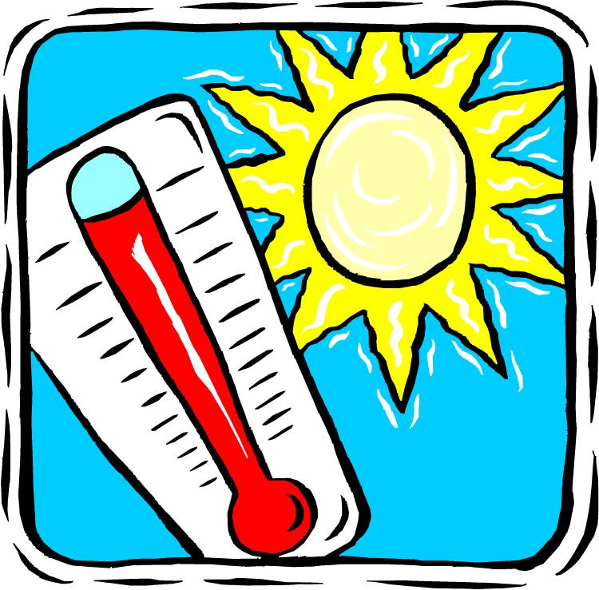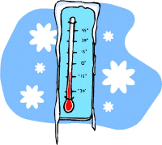

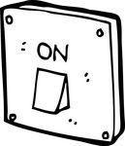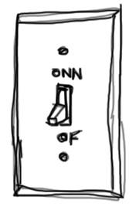2. A shadow is a place where _________.

a) no light is shining b) light is shining

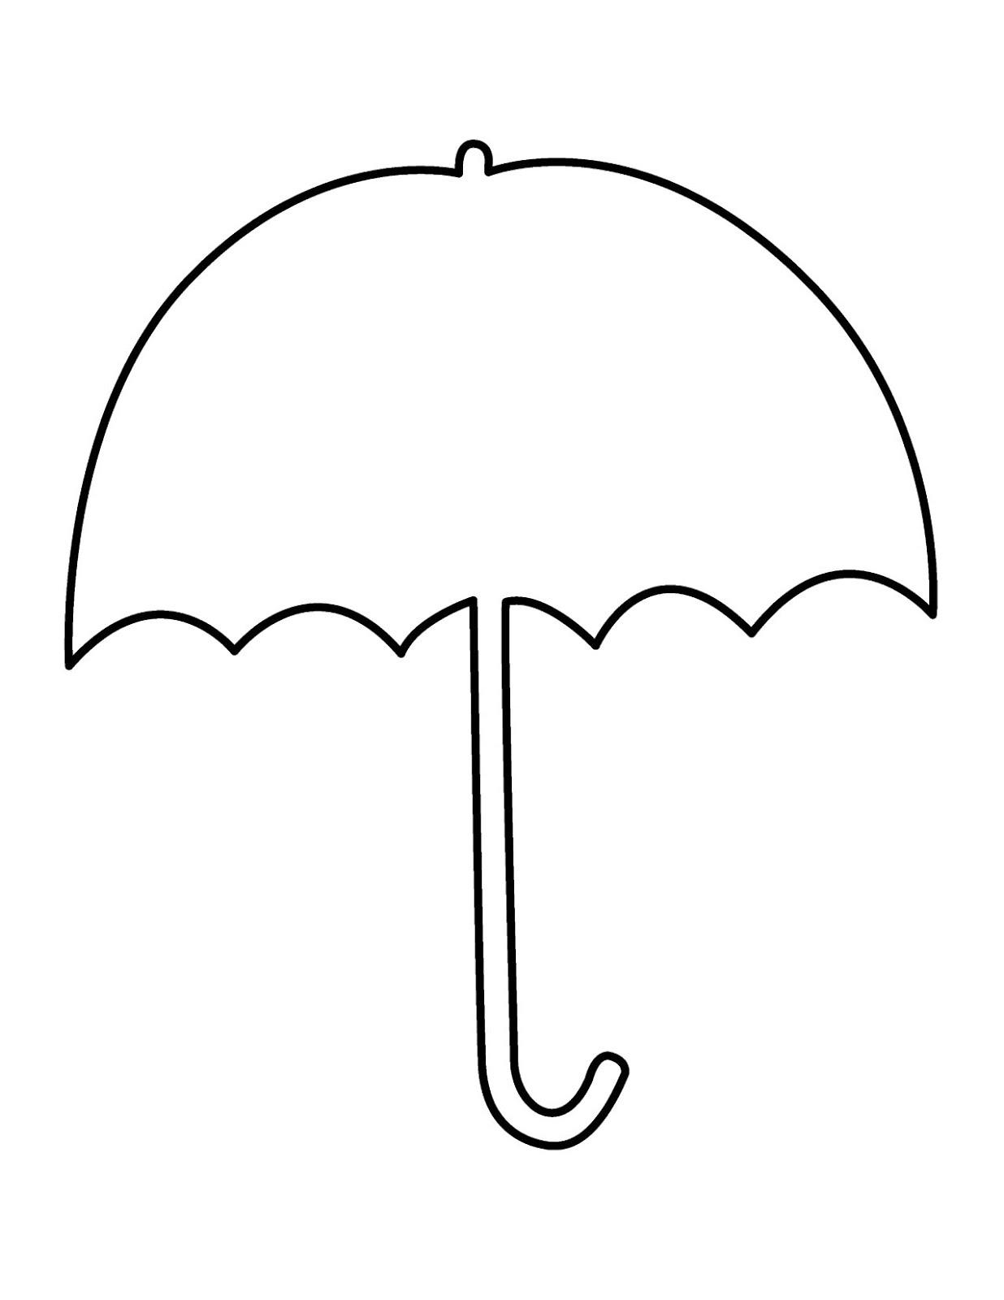3. What can we use to make shade?



a) umbrella b) pencil

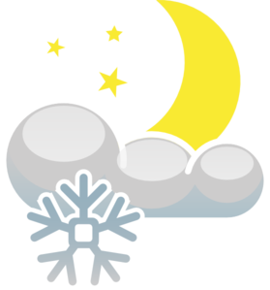4. Shade can help protect us from _____.



a) sunlight and heat b) moonlight and snow

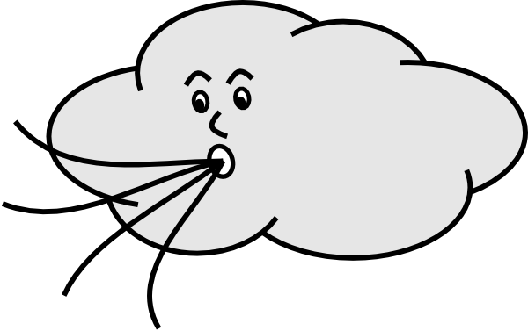5. What makes the shade cool?



a) no light under shade b) the wind