Light Absorption: Ice and Rock

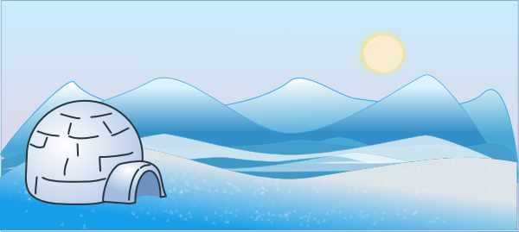
There are white and black paper under the sunlight. Which would get hotter? The answer is black paper! It is because the color black takes more heat from the sun than white.

Do you know that white paper represents ice and glacier on the Earth? Ice on the Earth reflects the sunlight. Ice helps the Earth to be cool!

Black Paper represents rock. Our land is made out of rock, and rock absorbs heat. Therefore, rock is hotter than the ice under the sun!

Name:__________________ Date:_________

Direction: Circle the correct answer.

1. What does white paper stand for?

a) Ice and Glacier b) Rock

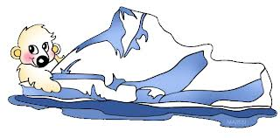
2. What does black paper stand for?

a) Ice and Glacier b) Rock

3. What does Rock do?

a) It reflects the sunlight b) It absorbs the sunlight

4. What does Ice do?

a) It reflects the sunlight b) It absorbs the sunlight

5. Which one gets hotter under the sun?

a) Ice and Glacier b) Rock

