Teacher Key
1. What does white paper stand for?

a) Ice and Glacier b) Rock

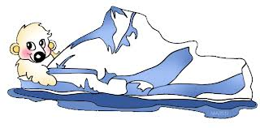
2. What does black paper stand for?

a) Ice and Glacier b) Rock

3. What does Rock do?

a) It reflects the sunlight b) It absorbs the sunlight

4. What does Ice do?

a) It reflects the sunlight b) It absorbs the sunlight

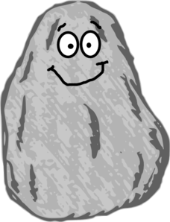
5. Which one gets hotter under the sun?

a) Ice and Glacier b) Rock

