Teacher Key

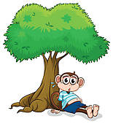
1.)

Eyes Skin

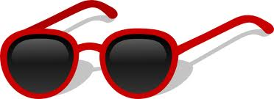

2.)

Eyes Skin

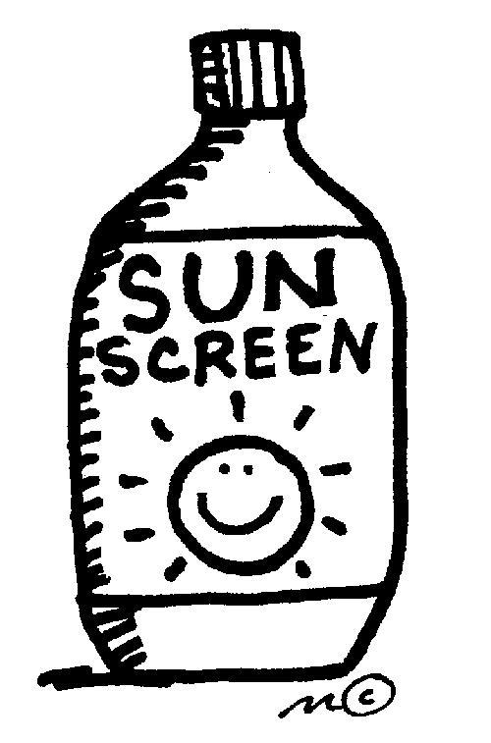

3.)
Eyes Skin

4.

Eyes Skin

5. What can happen if you stand in the sun for too long?
You can get sunburned.

