Animal Pyramid (Instructor)

Objective: To be able to distinguish which organisms belong in which category. & why

Materials:
- A print out of a pyramid separated into four sections: producers, primary consumers, secondary consumers.
- Gummy snacks: gummy bears (consumer), gummy fish (consumer), gummy berries (producers)

Procedure:
- Explain the different trophic levels using the powerpoint or the student’s printout of the lab that has a diagram of the trophic levels.
- Distribute the pyramid print out and one gummy from each trophic level (bear, fish, and berry) to each individual.
- Instruct them to identify each organism and place them in their designated level.
- Create the pyramid as well so that they can check it after they have finished and explain why each organism belongs where it belongs.
- Eat the gummies!

Post Lab Question Answers:
1. Top
2. Bottom
3. Middle

Animal Pyramid (Print Out)
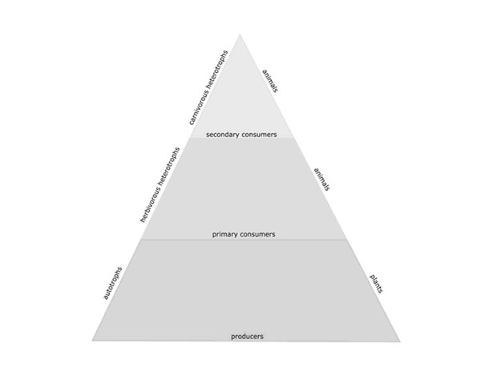

Post Lab Questions

1. If there was a wolf gummy where would it belong? Circle the answer choice
- Top Middle Bottom

2. If there is a flower gummy where would it belong? Circle the answer choice
- Top Middle Bottom

3. If there is a bunny gummy where would it belong? Circle the answer choice
Top Middle Bottom

