Sun's Effect on Earth's Surface Experiment

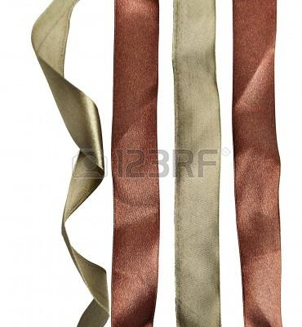
Purpose: To see what affects the sun has on different object placed in different locations.
Materials:
4 strips of cloth
Bowl of water

Procedure:
1. Cut a cloth into 4 identical strips
2. Submerge all the strips in the bowl of water.
3. Find five different places to put your cloth strips
4. Record the locations on piece of paper.
5. Have the students predict where the cloth will dry the fastest. Number 1 for the fastest to dry and 4 would be the slowest to dry. Use the handout for this.
6. Check the strips every 10 minutes.
7. Have students compare the results with their predictions

Student Worksheet
Sun’s Effect On Earth’s Surface Experiment
Name ___________________________

Number where you think the piece of wet cloth will dry fastest to slowest. Rank the following areas from 1 to 4, with one being the fastest drying area and four being the slowest drying area.

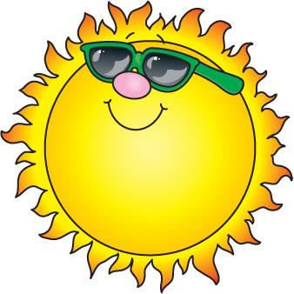

Predictions Rank 1-4 Area Final Results
Next to a window
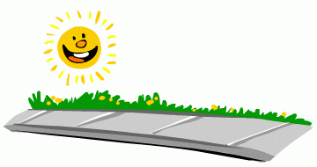
On the sidewalk
Under a tree branch in the shade
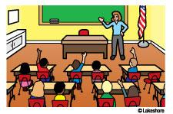
On classroom floor

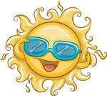
Questions:

1. How did you do on your predictions?

2. Why did the cloth dry fast in some places and slow in others?

3. Compare your predictions to what happened.

4. Where did it dry fastest?

5. Where did it dry the slowest?

6. How did the actual answers compare to your predictions?

