Teacher Key:

Predictions Rank 1-4 Area
2 | Next to a window
1 | 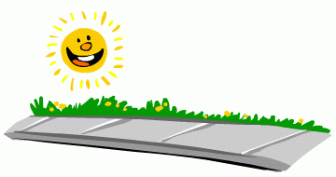  On the sidewalk
3 | Under a tree branch in the shade
4 | 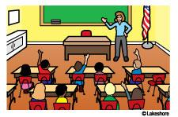  On classroom floor

Note: For the teacher key, the answers to the actual results should match the predicted results. Results may vary, depending on your surroundings.

Questions:
1. Answers may vary.
2. The sun gives off heat which dries the cloth.
3. Answers may vary.
4. On the sidewalk
5. On the classroom floor
6. Answers may vary. They should discuss if they are close or not close.

Conclusion: Students should see that the heat from the sun dries the strip of cloth. They should understand that the sun has different effects depending on the location.

