Growing plant in sunlight vs. in shade
Purpose: shows students how sunlight and shade affects the growth of plants.
Materials:
A place indoors to grow the beans and a place outdoors
8 bean seeds
4 small pots
water
ruler
potting soil
pencil
Procedure:
- Fill the 2 small pots with equal amounts of dampened potting soil.
- With a pencil, have students make holes about 2 centimeters deep in each pot.
- Place the 8 bean seeds, two per pot, and cover the seeds with some of the soil.
- Place 1 of the pots in the classroom in an area that will not receive bright sunlight
- Place the other pot outside so that it receives sunlight
- Be sure to water the plants as needed.
- Seeds will germinate within 7 days, and you can have your students begin making stem measurements. Take stem measurements for 14 days. Note the difference in stem length for each set of plants, and write down your observations

Student Worksheet
Growing Plants in Shade vs. in Sun
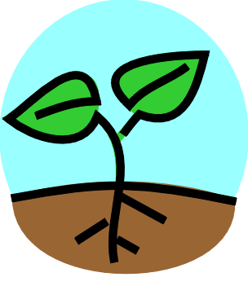
Name____________________________

Directions: Every two days for two weeks, record the length of the plants and record what you see. Remember to draw a picture of the plants too!

Table 1 (Indoors):

 | Picture | Observations | Length
1.
2.
3.
4.
5.
6.
7.

Table 2 (Outdoors):

 | Picture | Observations | Length
1.
2.
3.
4.
5.
6.
7.

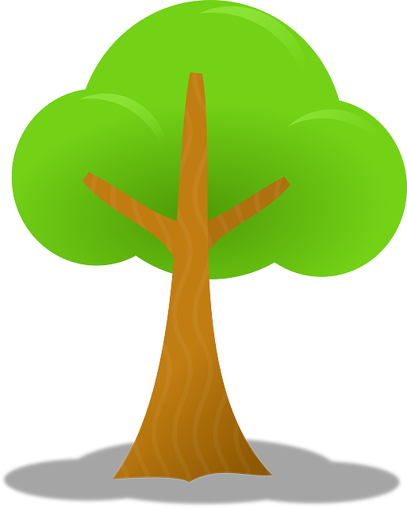

Questions:

1. Which plant grew taller?

2. How do plants get energy?

3. How did the shade affect the plant?

4. How much taller was the tallest plant?

5. What two other things do plants need in order to grow?

