Answer Key
Growing Plants in Shade vs. in Sun
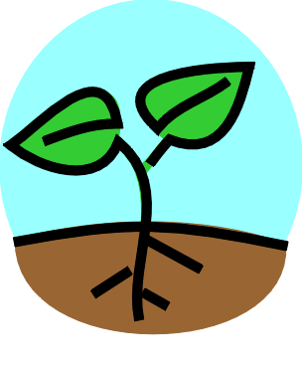
Name____________________________

Directions: Every two days for two weeks, record the length of the plants and record what you see. Remember to draw a picture of the plants too!

Tables 1 and 2 will vary.
Table 1 (Indoors):

 | Picture | Observations | Length
1.
2.
3.
4.
5.
6.
7.

Table 2 (Outdoors):

 | Picture | Observations | Length
1.
2.
3.
4.
5.
6.
7.

Questions:

1. Which plant grew taller?
The outdoor plant

2. How do plants get energy?

From sunlight

3. How did the shade affect the plant?

It reduced plant growth

4. How much taller was the tallest plant?

Answers will vary based on plant growth

5. What two other things do plants need in order to grow?
Soil and water

