Answer Key
Light Absorption: Black paper vs. White paper

Name____________________________
Directions: Measure and make sure the temperatures of both jars, which are covered with black paper and white paper, are same before putting them under sunlight. Then, check and record the temperature of both jars every 2 hours, maximum 6 hours, after putting them under the sun.
Data for temperatures will vary.
Time | Temperature of Jar with Black Paper | Temperature of Jar with  White Paper
(Before putting jars under the sunlight)
(2 Hours Later)
(4 Hours Later)
(6 Hours Later)

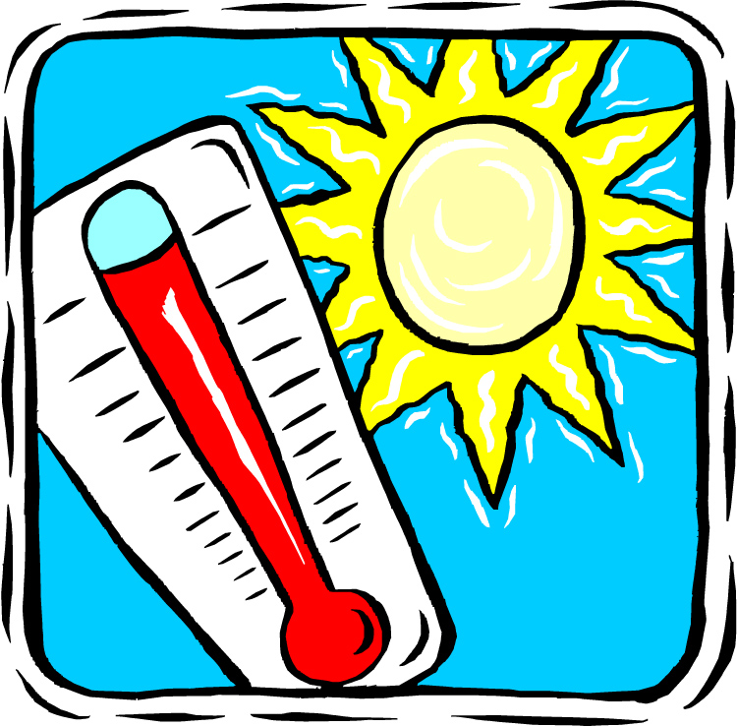

Name___________________
Questions

1. What happened to the temperature of the jar that was covered with white paper?
The temperature went up, but not that much.

2. What happened to the temperature of the jar that was covered with black paper?
The temperature went high, higher than white paper one.

3. Which jar was hotter?
The jar covered with black paper.

4. Why was the one jar hotter than the other?
Because black paper absorbs heat more than white paper.

5. What do black paper and white paper represent?
Rock and land for black paper, ice and glacier for white paper

