What is a Thermometer Questions

1. What does a thermometer do?

2. What do the numbers on it mean?

3. Why do you need a thermometer?

4. If it is 98.6 degrees Fahrenheit outside, is it hot or cold?

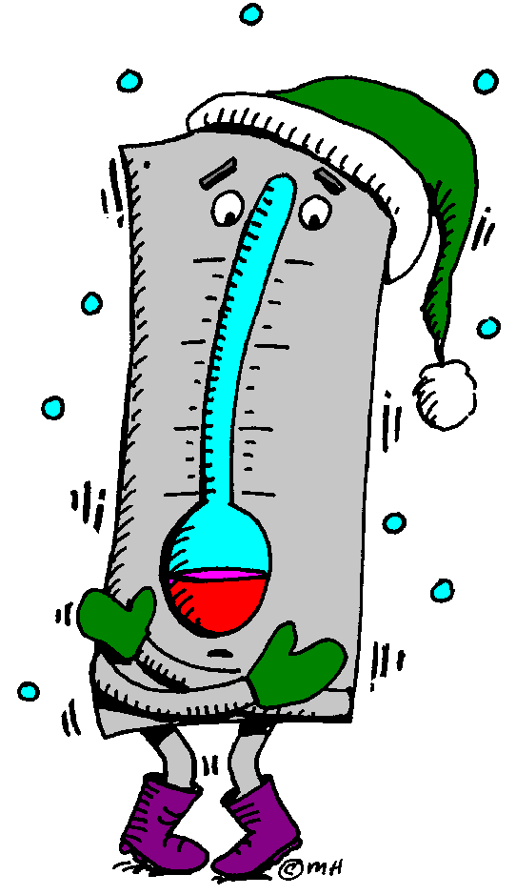
5. If it is 32 degrees Fahrenheit outside, is it hot or cold?

