Where do puddles go? Questions

1. Where did the puddle go?
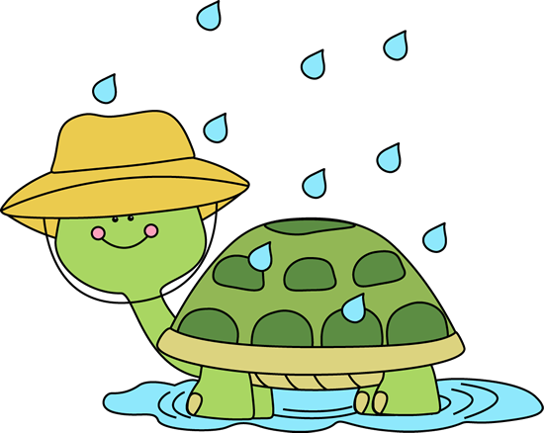
2. Why did the puddle go away?

3. What does evaporate mean?

4. What do you use instead of the sun in the experiment?

5. What do you use to hold the puddle in the experiment?
