Natural Disasters Quiz
1-3 Match the term to the picture
1) Magma
2)Lava
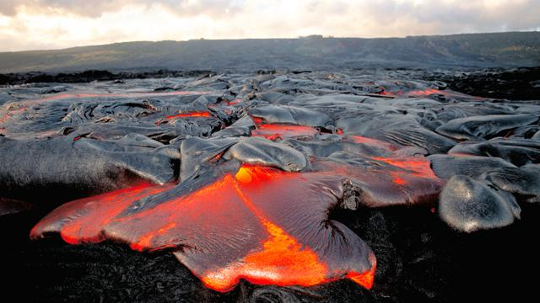
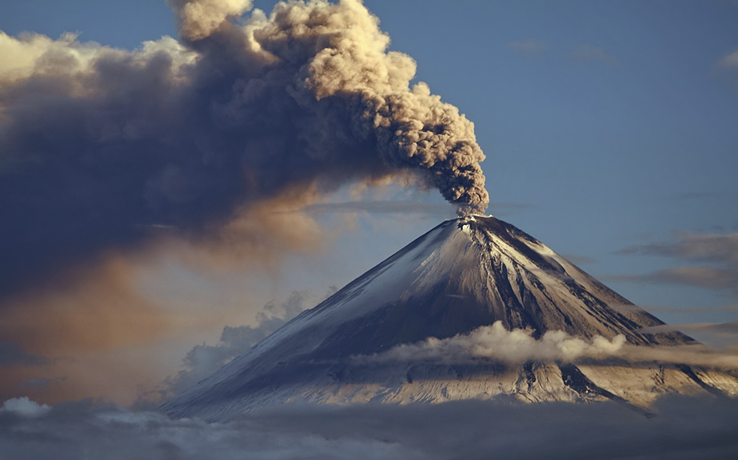
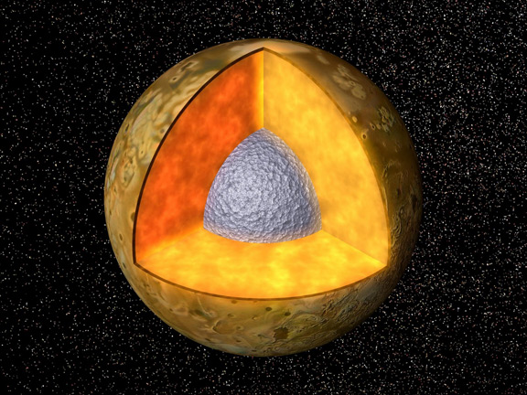
3)Volcano

Volcano Magma Lava

Match the definition to the term:
4) _b_a volcano that is tall, steep and made of ash and rock and lava
5) _a__a volcano that is dome shaped and has a slope and slow eruptions
6)__c_a volcano that is small, steep, and has explosive explosions
a) shield volcano
b)composite volcano
c)cinder cone volcano
7) What’s an earthquake?
a sudden and violent shaking of Earth, caused by movements within the crust or volcanism
Matching
8)Epicenter b a)amount of energy released from an earthquake
9)Magnitude a b) point of source of an earthquake

10) 90% of all tsunamis occur in the ….
a) Atlantic Ocean
b) Pacific Ocean
c) Indian Ocean
d)Arctic Ocean

11)Name any two from three natural disasters we learned about in class:
Answers can be any two from the three we learned: volcanoes, earthquakes, tsunamis
12)Circle ONE right tool that is used to detect earthquakes
seismographs telegraphs holograms

13) Circle TRUE or FALSE
Seismographs can be used to detect tsunamis.
True
14)Circle TWO correct tools that can be used help detect earthquakes
satellite tiltmeters thermometers

