Final Test

Multiple Choice:
1. Which of the following could increase the rate of chemical weathering of a rock?
a. | moving it to a location with few plants and animals
b. | moving it to a drier climate
c. | increasing its total surface area
d. | moving it to a colder climate

2. In which of the following climates would chemical weathering most readily occur?
a. | wet and warm | c. | wet and cool
b. | dry and warm

3. Which of the following has the potential for the most erosion?
a. | water flowing across a flatland
b. | wind blowing materials in the air, against the force of gravity
c. | wind blowing materials down a slope
d. | water flowing down a steep slope

4. Which of the following could be a fossil?
a. a woman who lived 15,000 years ago found in a glacier
b. a penguin that lived 100,000 years ago found in a dry valley in Antarctica
c. a wasp inside a 30 million year old block of amber
d. all of the above

5. The body of an animal is more like to become more fossilized if it:
a. is buried deeply in the ground
b. is left on the surface of the ground
c. does not contain bones or hard parts
d. if it is left under the sun for a long time period

6. Fossils form under:
a. dirt
b. ash
c. mud
d. all of the above

7. The earth was formed around:
a. 3.8 billion years ago
b. 754 million years ago
c. 443 million years ago
d. 10 billion years ago

8. Which of the following is not an example of a trace fossil?
a. bone
b. footprint
c. shells
d. nests
9. Transpiration occurs in
a. humans b. insects c. animals d. plants
10. The water cycle occurs
a. during the daytime b. at night c. all the time d. when it is hot
11. How many times can the water cycle repeat?
a. twice b. fifty c. 500 d. infinite number of times
12. What is sea surface salinity?
a. the concentration of salt at the ocean's surface b. sailing on the sea c. study of the sea surface d. what’s under the surface of the sea
13. What makes thawing happen?
a. The ice is so slippery that it melts b. the temperature warms up c. it’s so cold that it thaws d. the ice cracks and it thaws

Short Answers:
14. What is the difference between weathering and erosion?
Answers may vary
Weathering: change the appearance of something through long exposure of air/water/nature
Erosion: removing pieces of rocks and transporting them to another by wind and water.
15. \What are the three types of weathering? Describe each of them.
1. Physical weathering: The breaking of rocks by: wind or rain, contraction, water freezing and thermal expansion
2. Biological weathering: Rocks are broken down by living things or decomposed broken by: lichens and tree roots
3. Chemical weathering: The breaking of rocks when water and rocks interact with each other to create a chemical reaction.
16. What can carve a valley and erode land as it moves across the Earth?
Rivers and streams
17. Define fossils.
The remains of a dead organism that has been buried in the ground for many years.
18. How many different types of fossils are there?
2
19. Name the different types of fossils.
Trace fossils and body fossils
20. Explain how fossils are formed.
As soon as an organism dies, it must be quickly buried in dirt. The hard parts of the organism is then preserved while the soft parts rot away.
21. What is plate tectonics?
is the movement of enormous sections of Earth’s crust—the plates.
22. What do you do when there is an earthquake during class?
DUCK AND COVER
23. What is the process of the formation of Igneous rocks?
The melted rock is called magma. When a volcano erupts the magma pours out. - When magma comes out of the volcano it is called lava. Once it cools it becomes igneous rock.
24. For problems 4-6, determine what kind of plate boundary, and explain what is going on in the movement of plates.
TRANSFORM PLATE BOUNDARY: two (or more) tectonic plates or fragments of the lithosphere move toward one another and collide.

True/False:
25. True/ False When temperatures rise to a certain point, water becomes solid
26. True/ False Water’s gas form is called ice
27. True/ False Clouds are made up of ice and water vapor
28. True/ False Hail is created inside the cloud
29. True/ False we will run out of water completely at some point because it does not rain enough in California

Fill in the Blank:
30. In total, scientists have discovered _5_ mass extinctions.
31. ______Paleontology____ is the study of fossils.
32. The 6th mass extinction will most likely be caused by ___humans____.
33. __Condensation___ occurs in the sky after evaporation.
34. __Erosion___ is the process of removing small particles off from a surface.

Picture Questions:
35.
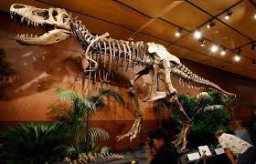
According to the picture, this fossil belongs to with animal?
A dinosaur
36.
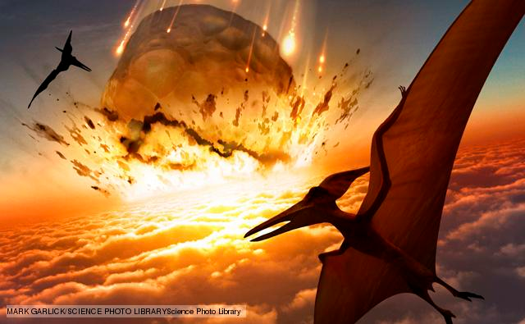
This picture shows the 5th mass extinctions. Why is this mass extinction so famous? What killed the creatures?
This mass extinction is when all the dinosaurs died. A meteorite killed all of them.

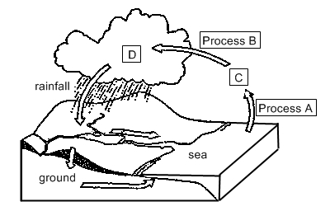

Use the diagram above to answer the following questions
37. In what state of matter is C?
_________gas_________
38. What is process A called?
________evaporation__________

39. In this picture, what is the term for the scraps that are broken in the rock?
SEDIMENTS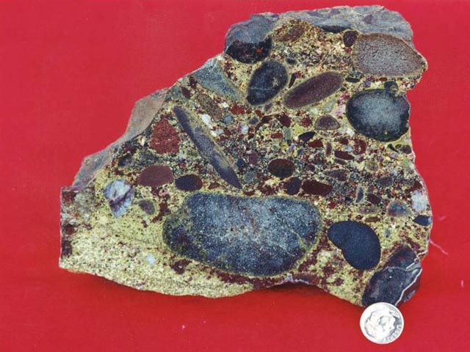40. In this picture below, what kind of rock is this? METAMORPHIC ROCK