Plants Quiz:
Good Luck!
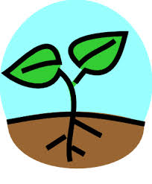
1-3
Name the parts of the plant:

1)

2)

3)

- Where does the energy come from that hits the plant?

- From the Lab, what were the two main factors plants needed, in order to grow?

Teacher's Answer sheet:
- Leaf
- Stem
- Root
- sun
- sun and water

