Plate Tectonics Article:
http://www.kidsgeo.com/geology-for-kids/0043-plate-tectonics.php

Plate Tectonics
Using modern equipment, scientists known as oceanographers have been able to measure and map out the ocean floor. What these scientists have discovered has helped explain how it is that continents are able to move around on the Earth’s crust.
Located deep beneath the waves on the ocean floor almost exactly halfway between the continents are raised areas known as ridges. These ridges are similar to under-water mountain ranges. At other locations we find extremely deep trenches, some reaching many thousands of feet in depth.
Many scientists believe that the ridges represent areas where new crust is being formed as hot magma escapes from the Earth’s core and spreads outward. As the seafloor spreads outward away from the area where magma is being released, the continents are carried across the sea, riding on top of the sima crust.

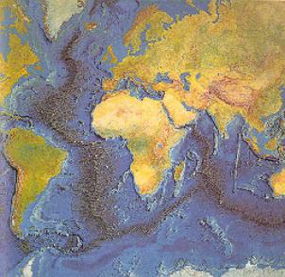
As new crust is created, older crust submerges back into the mantle, being melted once again. It is believed that the deep ocean trenches are locations where crust is being lowered back into the Earth’s core.
The amount of time that it takes for crust to be created and later destroyed is approximately 100 million years. Thus, most crust has a lifetime of around 100 million years.
Because continents do not fall back into the Earth’s mantle, they survive much longer. Many parts of the continents we see today are almost as old as the Earth itself.
As new crust is created in a particular location on Earth, it forms what resembles giant plates. One side of the plate is where new crust is being created, while the other side is where older crust is being destroyed.

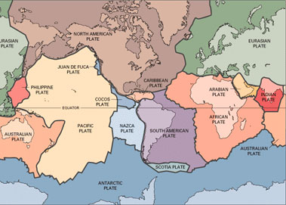
Geologists refer to this process as plate tectonics. As we study plate tectonics, a picture emerges of very old continents riding on top of much younger and ever moving plates. These plates move extremely slowly, at a rate of only about 10 cm per year.

Plates Boundaries
At the locations where two tectonic plates interact, a boundary between these plates exist. There are three types of boundaries that geologist observe. These boundaries are divergent boundaries, convergent boundaries, and transform boundaries.

Student Worksheet:

1. What are oceanographers, and what do they do?

2. About how long does it take for the crust to be created and later destroyed?

4. What are the three types of boundaries that geologists observe?

5. Explain in your own words the process of plate tectonics.

6. At what rate do the plates move at?

7. It is believed that that what are locations where crust is being lowered back into the Earth’s core.

8. What happens when the new crust comes to get rid of the old crust? What happens to the old crust?

