Student Worksheet:
1.What is the objective?
2. What is the purpose of the experiment?
3. Is a soundwave something that travels through air? Explain.
4.What materials are needed for this lab?

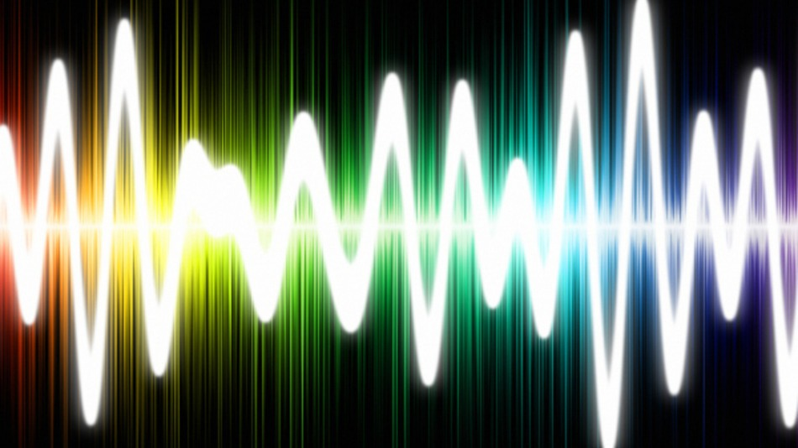

Teacher Key:
1.To determine if sound travels best through the air, water or a solid.
2.It is to test how sound travels through the three phases of matter and to see if one of these phases transfers sound better over greater distances.
3. No, the soundwave actually travels through molecule by molecule and travles better in liquid than in gas and solid better than liquids.
4.A swimming pool
Two tin cans
20 meters of heavy-duty string
A friend to help
An adult with a drill
(optional) A decibel reader

