Quiz #3

Sound Waves

Short Answer- Fill in the blanks with the correct answer.

- Where do sound waves come from? Sound comes from vibrations. These vibrations create sound waves which move through mediums such as air and water before reaching our ears.

- What is an echo? a sound or series of sounds caused by the reflection of sound waves from a surface back to the listener.

- Where does sound move fastest at? Sound travels fastest through a solid, because the molecules are most tightly packed together in a solid, helping the sound waves jump from one molecule to another faster. Sound travels second fastest through a liquid because the molecules are packed together second most, and sound travels slowest through gasses.

4. What is the process of using reflected sound waves to find objects called?
Echolocation

- What animal emits high frequencies that help them locate things?
Bats
- What is the explosive sound heard when a shockwave reaches your ear?
Sonic Boom

True/False – On the line provided, please write True or False.
- We use our ears to hear vibrations which turn into sound. ___True_______
- Sounds that are too loud are unhealthy for our ears. ___True__________
- The Cochlea is filled with tiny hair cells.______True _____
- Number the events 1-4 for the correct order in which they occur.
____3_____ Electrical signals sent to the brain
_____2_____ Sound waves travel to cochlea
____1_____ Sound waves travel to eardrum through ear canal
____4_____ Brain interprets sound

BONUS: Circle the picture that represents a sound wave.
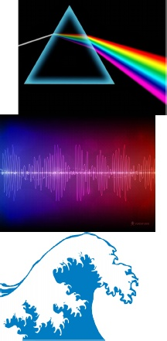

the middle picture.

