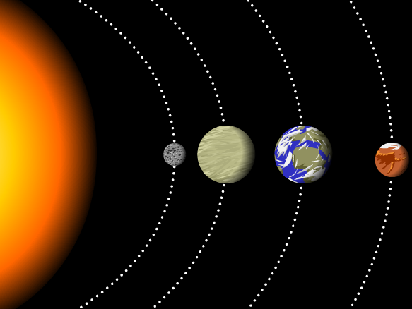
1) What is the name of the first planet that is closest to the Sun?
a. Earth
b. Jupiter
c. Mercury
d. Saturn

2) How many planets are there in the solar system?
- 7
- 8
- 9
- 0

3) The sun is a
- galaxy
- planet
- star
- ball of gas

4) Which planets have rings
- Mars, Jupiter, and Saturn
- Saturn, Pluto, Neptune, and Venus
- Jupiter, Saturn, Uranus and Neptune
- Jupiter, Saturn, Neptune, and Venus

5) The Moon is unlivable compare with Earth because
- there is no air to breathe
- there is no water to drink
- the surface temperature can be hotter than boiling water
- all of the above

6) A small piece of rock and metal that travels in space around the sun?
- Nebulae
- Meteorite
- Meteoroid
- Planet

7) Which is smaller?
- Sun
- Earth
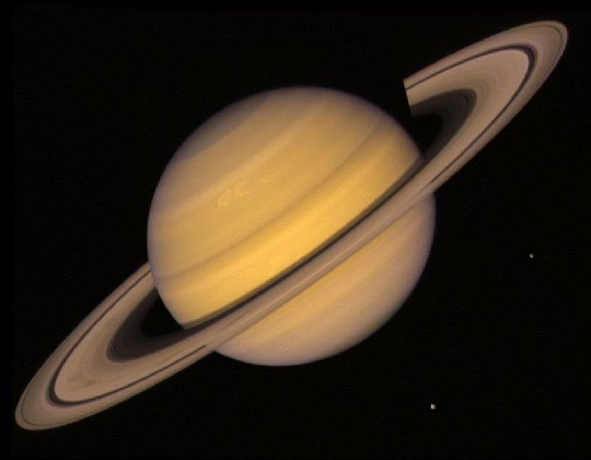
8) What planet is this?
a. Earth
b. Jupiter
c. Uranus
d. Saturn

9) The last four planets, also known as the outer planets, are
- Mercury, Venus, Earth, Mars
- Earth, Jupiter, Saturn, Venus
- Pluto, Saturn, Neptune, Mercury
- Jupiter, Saturn, Uranus, Neptune

10) The first four planets are
- Neptune, Uranus, Saturn, Jupiter
- Mercury, Venus, Earth, Mars
- Jupiter, Saturn, Uranus, Neptune
- Saturn, Pluto, Earth, Mercury

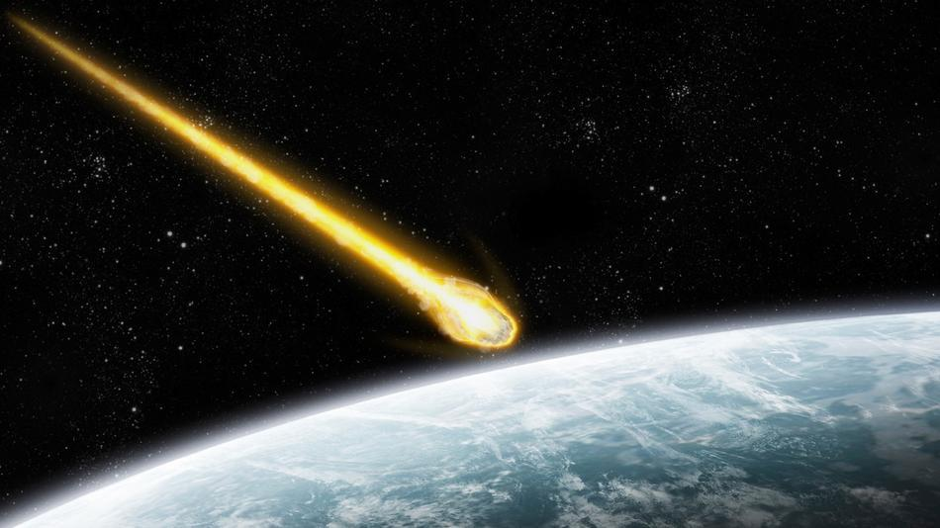
11) What is the picture above showing?
a. a meteorite
b. a star
c. the Sun
d. None of the above

12) Which planet is known as the "Red Planet?"
- Mars
- Earth
- Venus
- Saturn

13) Which is most reponsible for seasons?
- how close we are to the sun
- the earth's rotation
- the earth's tilt
- all of the above
- None of the above

14) This planet is the largest of the inner planets. Its surface is mostly covered in water, giving it a bluish appearance from space. This planet rotates every 24 hours.What is the name of this planet?
- Earth
- Mercury
- Mars
- Venus
15) The is the center of our solar system.
- earth
- sun
- moon
- asteroid belt

