Name: ___________________________________ Date: _________________

Test

Directions: Choose the best answer from the options provided.

1. ____________ is the energy obtained from food.
A. life cycle
B. nutrient
C. diet
D. inheritance

2. __________ is an omnivore; __________ is a herbivore; __________ is an amphibian; __________ is a carnivore.
A. human, deer, frog, cheetah
B. frog, cheetah, human, deer
C. deer, frog, human, cheetah
D. cheetah, frog, deer, human

3. What is natural selection?
A. It is the behavior of a species living under specific environmental conditions.
B. It is the ability to continue living in harsh conditions.
C. It is part of plant that supports it.
D. It is the concept that those who have the best traits for an area survive longer in that area.

4. Which of the following is not a genetic trait from inheritance?
A. favorite color
B. hitchhiker’s thumb
C. hair color
D. dimples

5. Which of the following is a mammal?
A. People
B. Dogs
C. Mice
D. All of the above

Directions: Match the following vocabulary words to the correct answer.

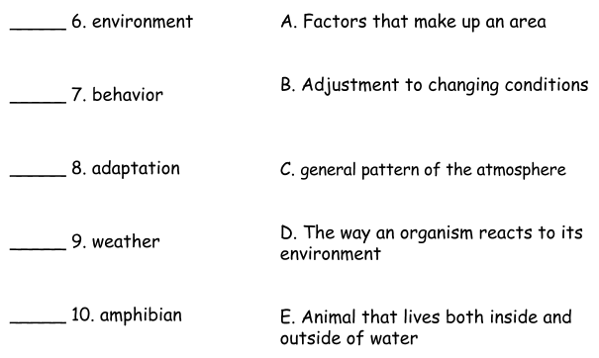

Directions: Circle T for True and F for False.

11. T / F Behavior is the process of passing genes from parents to offspring

12. T / F An example of a trait is the brown fur on a dog.

13. T / F All animals go through metamorphosis.

Directions: Answer the following questions in 2 - 5 sentences.

14. What is the difference between nature vs. nurture?

15. What are the stages of a life cycle of a butterfly?

