Unit Test- Teacher Key
Connect the word with definition.

1. thermometer b a) to supply with sufficient
amounts of fluid or moisture
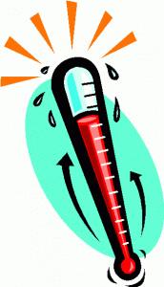

2. shade e b) a tool used to measure
temperature

3. sun g c) a large mass of stone

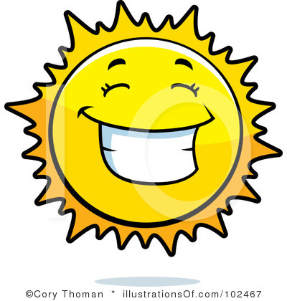

4. rock c d) a sore red state of the skin
caused by too much sunlight
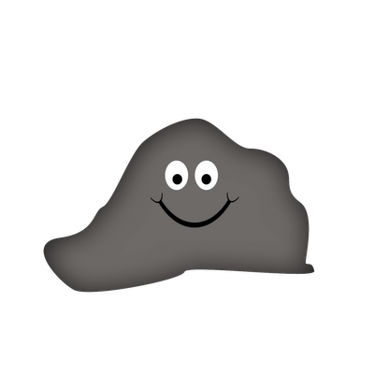
5. hydration a e) to shelter from the sun or
light
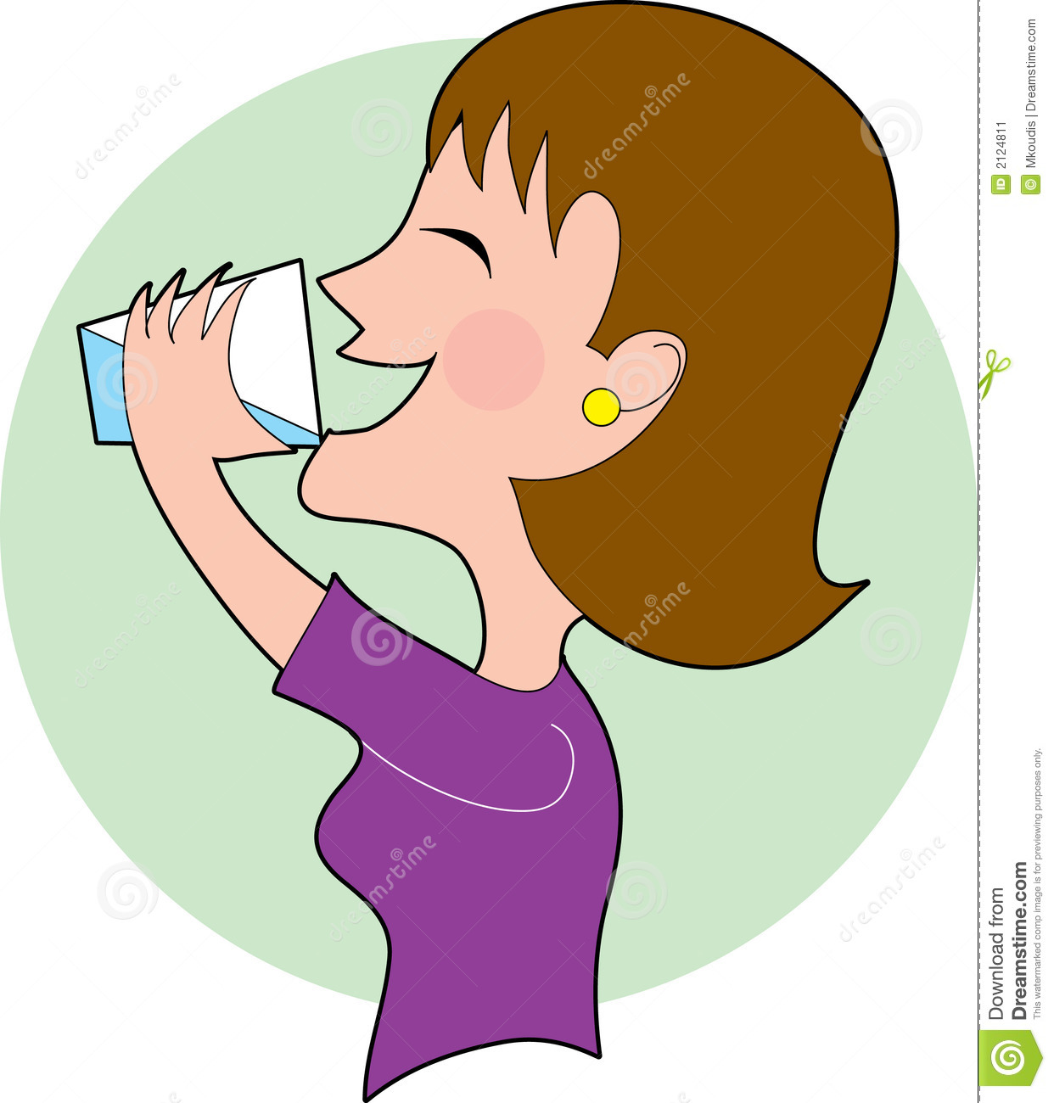

6. umbrella f f) a collapsible covering for
protection against weather
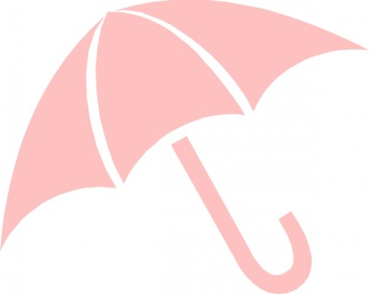

7. sunburn d g) a star and the biggest object
in the Solar System (it’s very hot!)
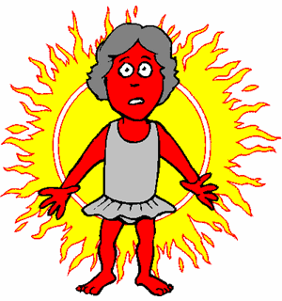
Circle the correct answer

8. We get light energy from ________.
a) Sun b) Soil

9. Shade keeps us _______.

a) Hot B) Cool
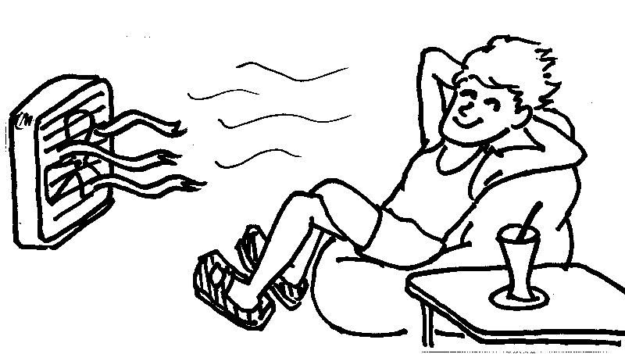
10. Which color absorbs heat more?

a) Black b) White

11. What does sun help to grow?

a) Plant b) Ice cream

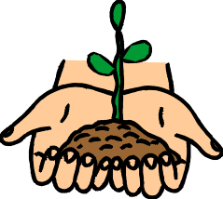

12. What does a thermometer do?

a) It gives the Earth energy b) It measures temperature
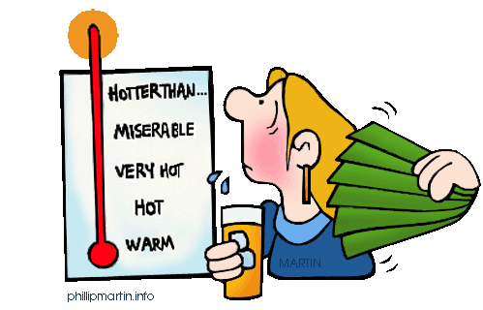

13. What do sunglasses protect from the sun?
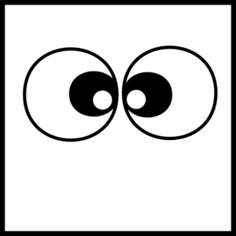
a) Skin b) Eyes

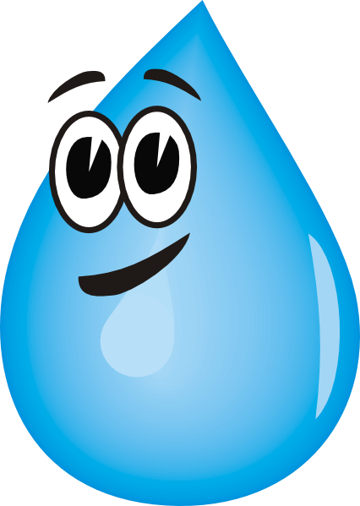
14. What helps us to be hydrated?

a) Heat b)Water

15. A shadow is a place where _________.

a) no light is shining b) light is shining

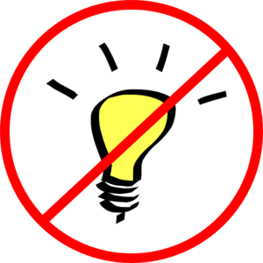

16-20 Name the Pictures (Use Word Bank)
<Word Bank>
Hat / Winter / Seed / Desert / Sand
16) 17)
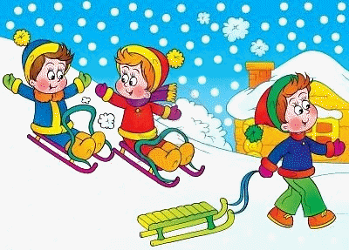

________hat_________ ________winter_________

18) 19)

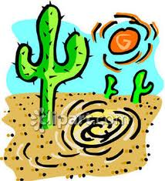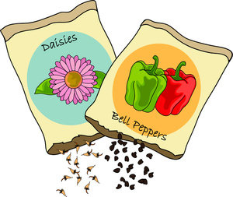

_______desert_______ _______seed_______

20)

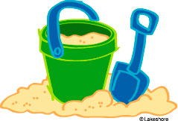

_______sand_______

