Name: _______________

Sun Safe Play Everyday!

Questions:

- What does the sun help grow?
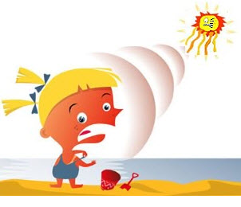

- What do trees protect us from?

- The sun gives us ___ and ____.

- What can sunrays cause to our skin?

5) What should we wear when we play outside?

