Name: _______________

What is Shade?
Questions:

1) What is hotter? Inside or outside?

2) What does the shade do?

3) What is the arrow pointing at?
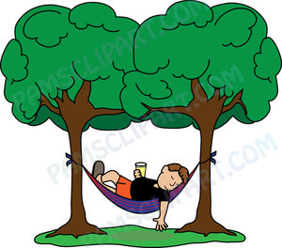
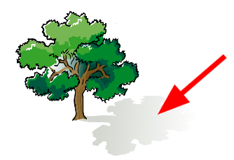

Answer: ______________

4) What does the shade protect you from?

5) The sunlight makes the ground ___________.

