Teacher Key

Outer Space: "I'm So Hot"

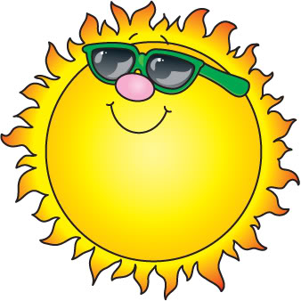
Questions:

- What is the sun made out of?
Hydrogen and helium

- How hot is the sun?
48 million degrees

- The sun helps grow what?
Plants

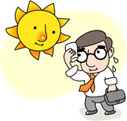
- The sun makes ____ dry.
Deserts

- What do you feel if the sun is not around?
Cold

