Water Cycle Quiz
True/ False
Circle whether or not the following statement is true or false
1. True/ False When temperatures rise to a certain point, water becomes solid
2. True/ False Water’s gas form is called ice
3. True/ False Clouds are made up of ice and water vapor
4. True/ False Hail is created inside the cloud
5. True/ False we will run out of water completely at some point because it does not rain enough in California
Multiple Choice
6. Transpiration occurs in
a. humans b. insects c. animals d. plants
7. The water cycle occurs
a. during the daytime b. at night c. all the time d. when it is hot
8. How many times can the water cycle repeat?
a. twice b. fifty c. 500 d. infinite number of times
9. What is sea surface salinity?
a. the concentration of salt at the oceans surface b. sailing on the sea c. study of the sea surface d. what’s under the surface of the sea
10. What makes thawing happen?
a. The ice is so slippery that it melts b. the temperature warms up c. it’s so cold that it thaws d. the ice cracks and it thaws
11. What source of energy evaporates the most water from Earth’s surface?
a. volcanoes b. the sun c. lightning d. wind
12. What controls whether water is a gas, liquid, or solid ice?
a. the shape or size of the cup b. where it has been stored c. if it is being used for irrigation d. what its temperature is

13. On what kind of day would you expect the most evaporation from the surface of a pond?
___________________

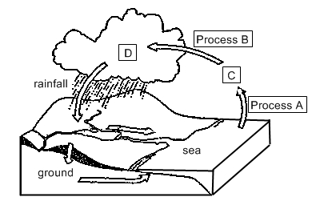

Use the diagram above to answer the following questions
14. In what state of matter is C?
__________________
15. What is process A called?
__________________

