Weathering and Erosion Quiz Teacher Key:
Short Answers
1. What is the difference between weathering and erosion?
Answers may vary
Weathering: change the appearance of something through long exposure of air/water/nature
Erosion: removing pieces of rocks and transporting them to another by wind and water.
2. \What are the three types of weathering? Describe each of them.
1. Physical weathering: The breaking of rocks by: wind or rain, contraction, water freezing and thermal expansion
2. Biological weathering: Rocks are broken down by living things or decomposed broken by: lichens and tree roots
3. Chemical weathering: The breaking of rocks when water and rocks interact with each other to create a chemical reaction.
3. What can carve a valley and erode land as it moves across the Earth?
Rivers and streams
4. How have humans caused erosion?
Humans divert surface water or concentrate its flow and increase slope angles (again usually during some form of construction) we can increase the potential for erosion.
5. Name the three sizes of soil particles, from largest to smallest.
Clay, silt, sand

Multiple choices
7. Which of the following could increase the rate of chemical weathering of a rock?
a.  b.  c.  d. | moving it to a location with few plants and animals  moving it to a drier climate  increasing its total surface area  moving it to a colder climate
Answer: C
8. In which of the following climates would chemical weathering most readily occur?
a. wet and warm
b. dry and warm
c. wet and cool

Answer: A

9. Which of the following has the potential for the most erosion?
a. water flowing across a flatland
b. wind blowing materials in the air, against the force of gravity
c. wind blowing materials down a slope
d. water flowing down a steep slope
Answer: D
10. ____________________ is the removal and transportation of weathered material from one location to another.
Answer:
Erosion

11. What type of erosion caused the hole in the rock?
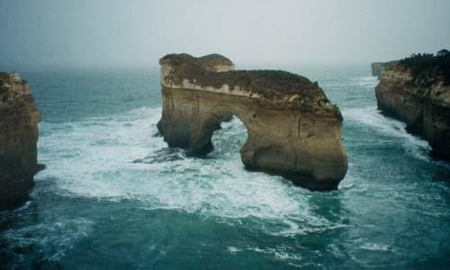
Water Erosion

