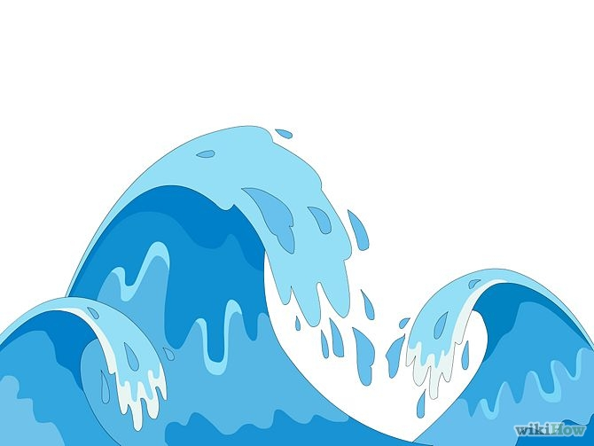
Waves & Currents

1. What are the distance between troughs and the distance between crests?

2. How are sound waves produced?

3. How do you find the frequency of a wave?

4. What are the low points of a wave?

5. What are the high points of a wave?

