Week 1 Quiz- Teacher’s Key

1. What gives Earth its light?
a) the sun b) the moon

2. We get heat energy from the sun.

a) True b) False

3. The sun provides ______ for the Earth

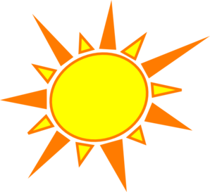
a) Light b) Water

4. Is it warmer at night or during the day?
a) Night b) Day

5. Plants need ______ to grow.
a) Sunlight b) Moonlight

