Teacher Key

1.What gives Earth its light?
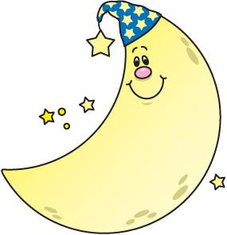
the sun the moon

2. What is the sun?
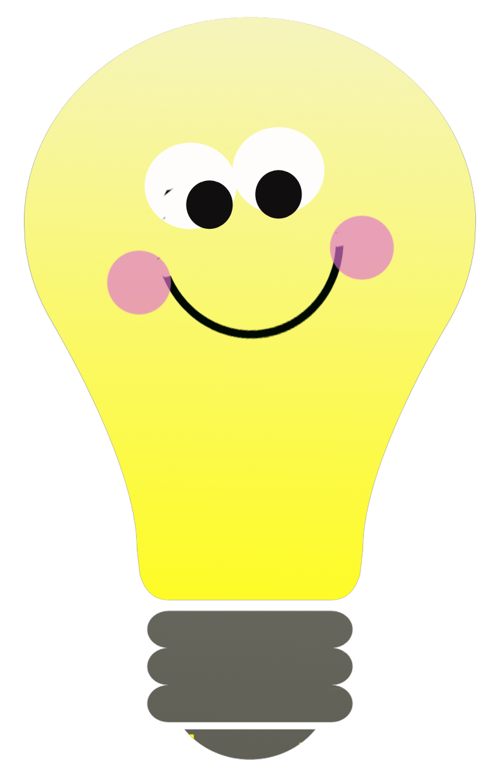

a light bulb a star

3.What is the sun made of?
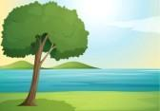
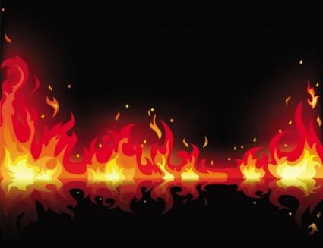

rivers and trees fire and gas

4. What planet is the sun close too?
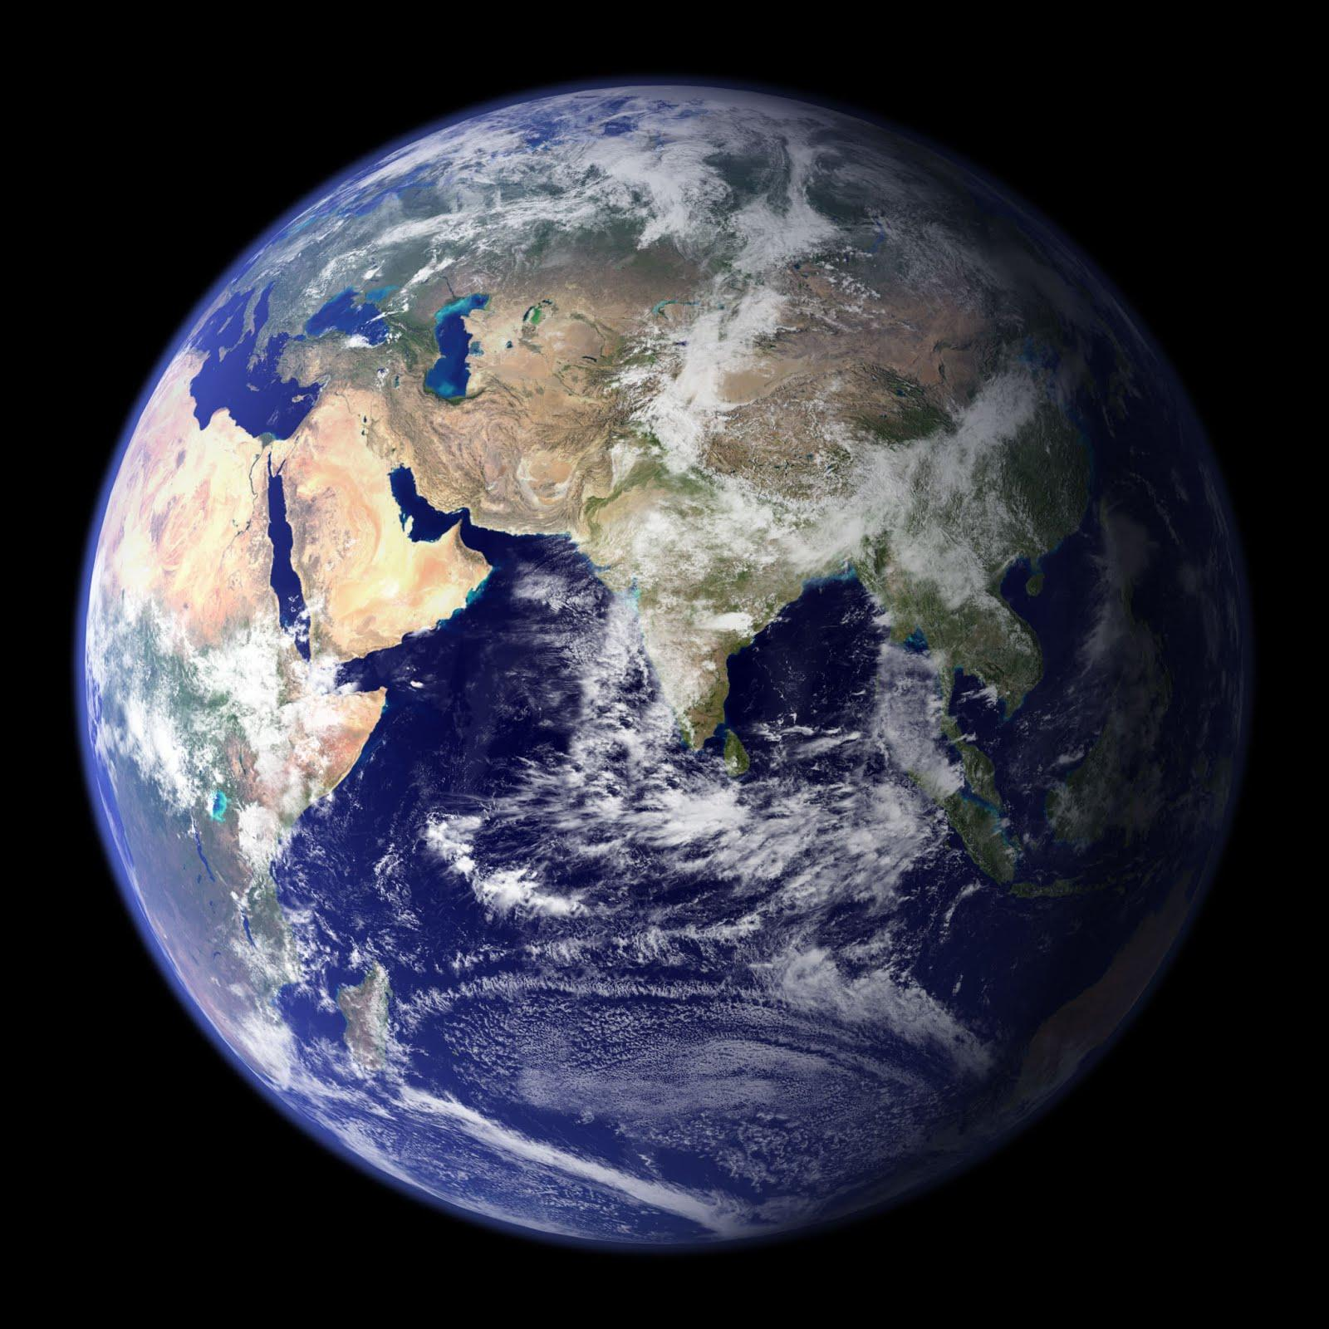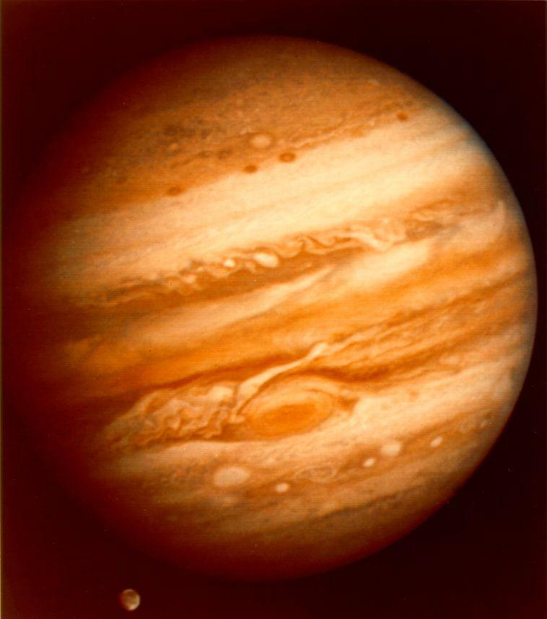
Earth Jupiter

5. What does the sun give to Earth?
Heat and light

6. Draw a picture of the sun!
The drawings may vary but should show a big bright sun, preferably with lines (representing heat and light) coming out of it. If the picture includes the Earth, be sure that the sun is separate from the Earth.

