Week 2 Quiz
herbivore omnivore carnivore

For questions 1-3, fill in the blank with the correct word from the word bank.
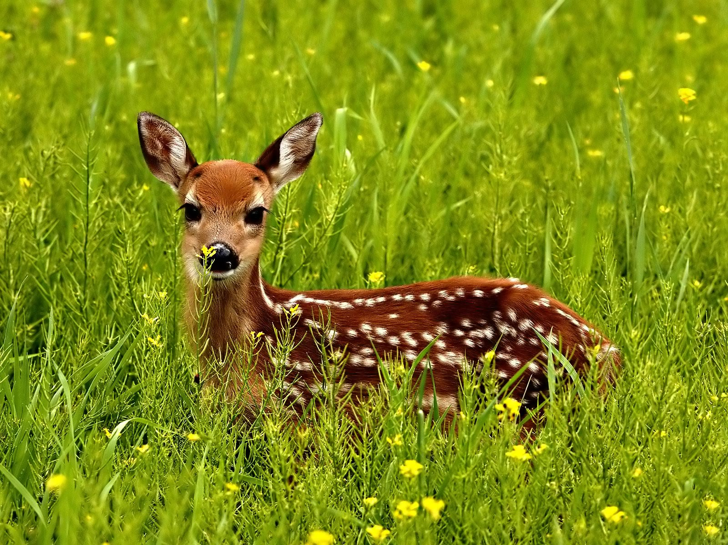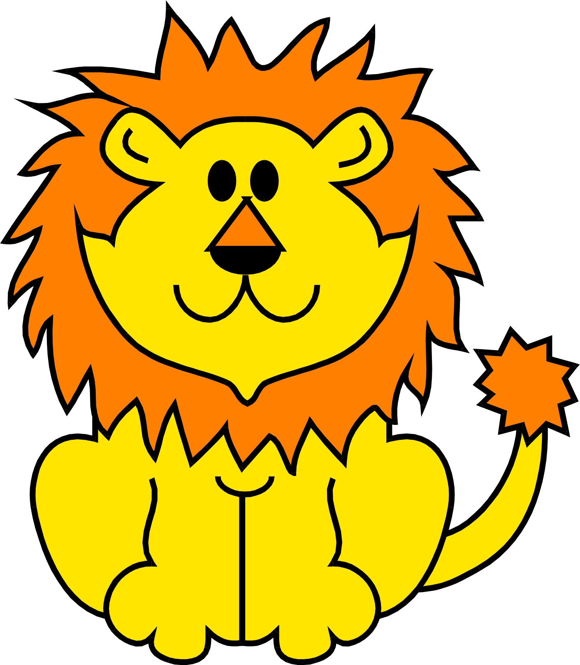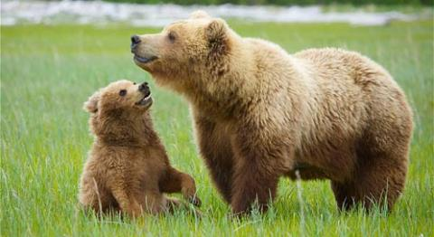
1. herbivore 2. carnivore 3. omnivore
4. Circle the picture of the animal that is a decomposer
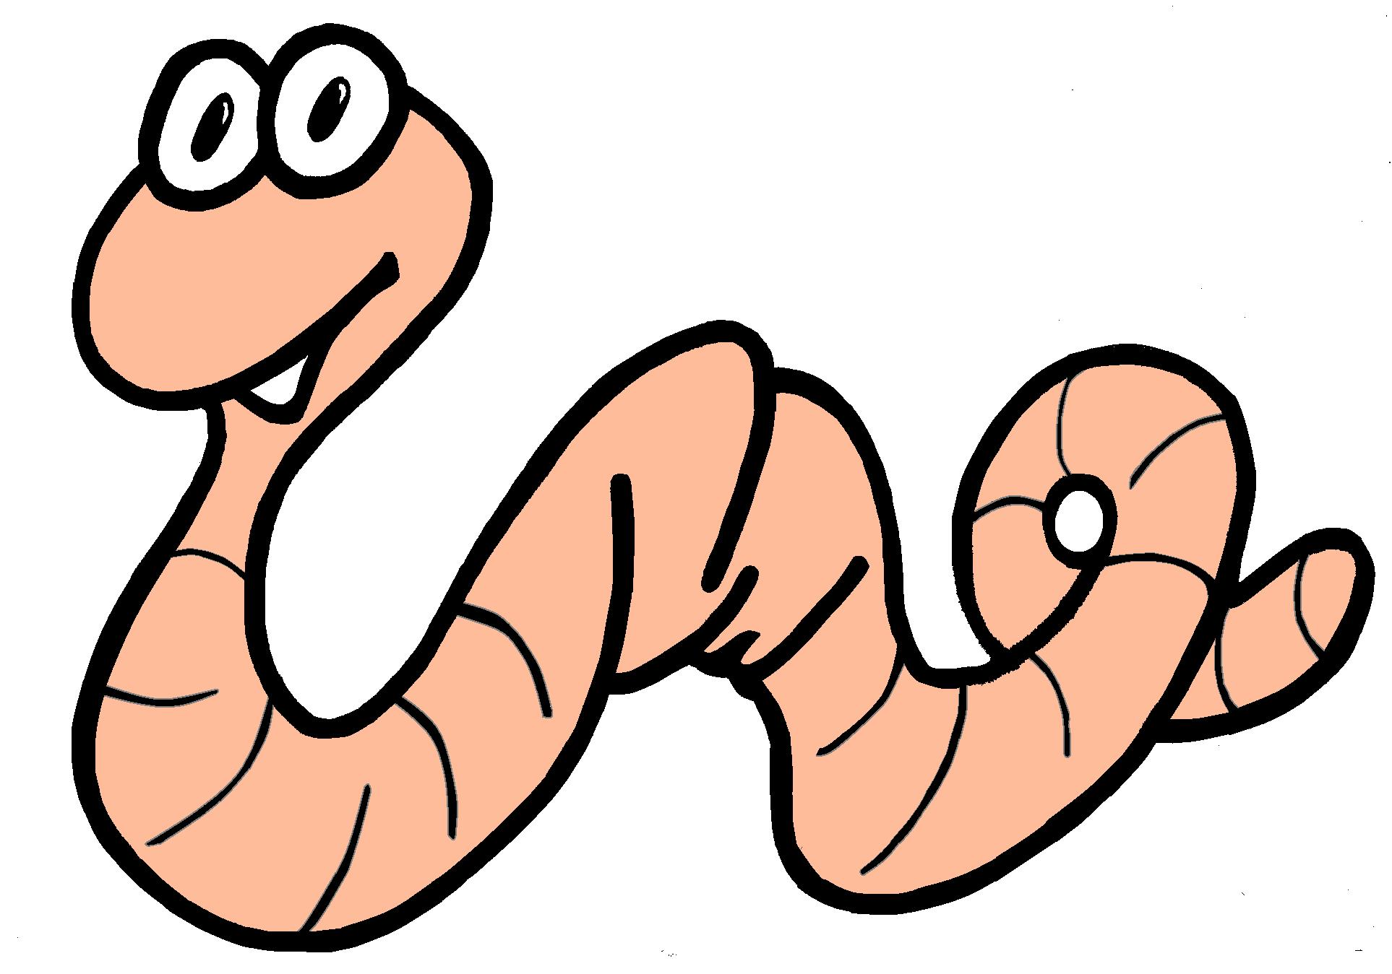
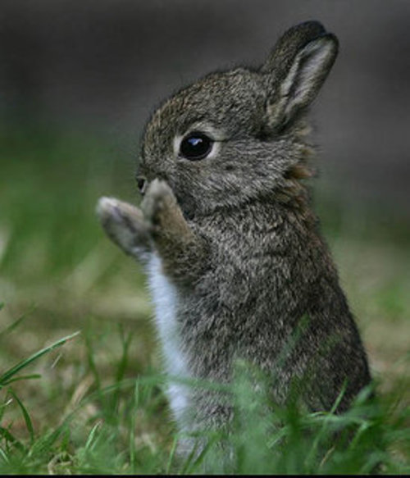
For questions 5-10, circle True or False
5. Keystone species are an important species True False
6. Humans use photosynthesis to get their food True False
7. Autotrophs make their own food True False
8. Heterotrophs make their own food True False
9. Flies are decomposers True False
10. Carnivores are animals that eat meat True False

