Week 2 Quiz- Teacher’s Key
1. All things that move or grow use ______.

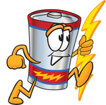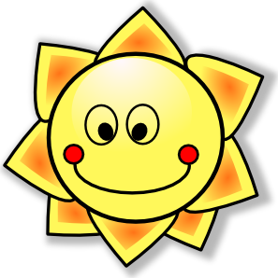
a) energy b) sun

2. Which would get hotter under sunlight?

a) black paper b) white paper
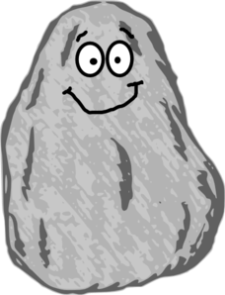
3. Darker objects, such as rocks and land:

a) absorb sunlight b) reflect sunlight

4. Lighter objects, such as ice and glaciers:
a) absorb sunlight b) reflect sunlight

5. The sun gives out ____.
a) water b) heat

6. It is better to swim in:
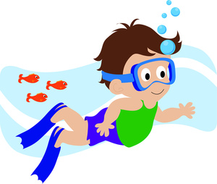
a) the winter b) the summer

7. ___ absorb heat.
a) dull and roughened surfaces b) smooth and shiny surfaces

8. ___ reflect light and heat rays.
a) dull and roughened surfaces b) smooth and shiny surfaces
