Teacher Key

Directions: For # 1-4, match the pictures to the right description.

1.)
#4 a place where no light is shining
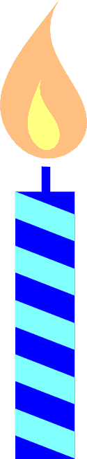
2.)
#1 a big bright star that gives Earth its light

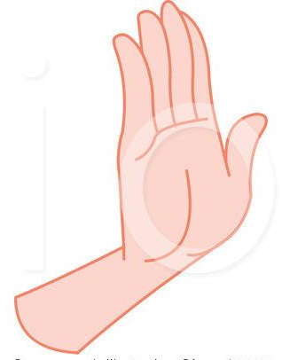
3.)
#2 a source of light

4.)

#3 something that can be used to block light

5.) Draw a shadow for the girl. Make sure it is in the right position. (Hint: look at where the sun is)

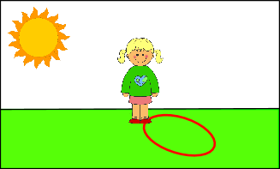
Any shape within this region is acceptable.

